

Contents

Introduction 4

1.0 Entity Relationship Diagram (ERD) 4

Limitations in the Initial Design 7

Enhancements in the Final ERD 7

Reflection on the ERD Design Process 9

2.0 Database Implementation and Data Manipulation 9

Data Insertion 10

Table Creation and Structure Overview 10

Student & Emergency Contact Tables: 10

Staff, RoleType & StaffRole: 11

Course & CourseOffering: 13

Class & ClassEnrollment: 14

Assignment & Student Submission: 15

Enrollment & Payment: 16

Certificate: 18

Campus & Department: 19

Pending View: 19

Constraints and Validation 21

Trigger and Automation 22

Reflection on Implementation 25

3.0 SQL Query Analysis and Business Insights 25

Show Names of Students and Their Enrolled Courses 25

Identify Students Who Never Enrolled 26

Students Enrolled Between Specific Dates 27

Students Living in the Same City 28

Instructor with the Fewest Students 29

Total Revenue Calculation 31

Certificates Issued Within a Defined Timeframe 32

Viewing Staff and Their Role Types 34

Advanced SQL: Identifying Active Students 35

Virtual Dance Course Management 36

Course Deletion with Linked Data 39

Deleting a Specific Student Record 41

Deleting 'Creative' Courses: 42

Update Emergency Contact Information 44

Updating Start Date for Student 'Adam' 44

Integrity Check on Each Table 45

Importance of Integrity Check and Testing Methods 46

Exporting View to PDF 46

Exporting Students Table to CSV 47

Power Query Profiling (Course Table) 49

4.0 Statistical Analysis 49

Course Popularity by Subject 51

Course Popularity by Level 52

Average Number of Reviews by Subject 52

Standard Deviation of Subscribers 53

National Distribution of Subscribers by Subject 54

Statistical Summary and Insights 54

LSEPI (Legal, Social, Ethical & Professional Issues) 54

Conclusion 55

References 56

Bibliography 57

# 

# Introduction

Leaf Village Training Ltd is a private educational provider offering creative courses across multiple campuses. Appointed as a data specialist, the task was to replace spreadsheet-based data handling with a secure and structured relational database system. Inefficient data practices in educational settings often lead to compliance risks, delays, and a lack of data traceability (Chaffey and White, 2022). A centralized database was therefore developed to support core operations such as enrolment tracking, staff roles, certificate management, and payment monitoring.

The system was built using SQLite, following best practices in relational modelling and third normal form (Connolly and Begg, 2021). SQL was used for implementation, data population, querying, and validation. Statistical methods were applied to analyze course popularity, and Power Query explored patterns in pricing and enrollment.

Legal, social, ethical, and professional issues were also considered throughout, including GDPR, ISO/IEC 27001 for information security, and the British Computer Society’s professional code (BCS, 2023), ensuring the system is secure, ethical, and compliant.

# 1.0 Entity Relationship Diagram (ERD)

An Entity Relationship Diagram (ERD) is a visual model that represents the structure of a database, including entities, attributes, and their relationships (Connolly and Begg, 2021). The ERD for Leaf Village Training Ltd. was designed through an iterative process to ensure data integrity, accuracy, and alignment with system requirements. However, further evaluation revealed several limitations that necessitated refinement. These modifications were made based on feedback, normalization principles, and scalability requirements (Coronel and Morris, 2018).

The initial version, although serviceable, used oversimplified structures that limited long-term adaptability. For instance, staff roles were stored in a single attribute within the Staff table, preventing the system from reflecting multiple responsibilities per staff member.

Similarly, the combination of course metadata and delivery data on the Course table restricted scheduling flexibility and led to data redundancy.

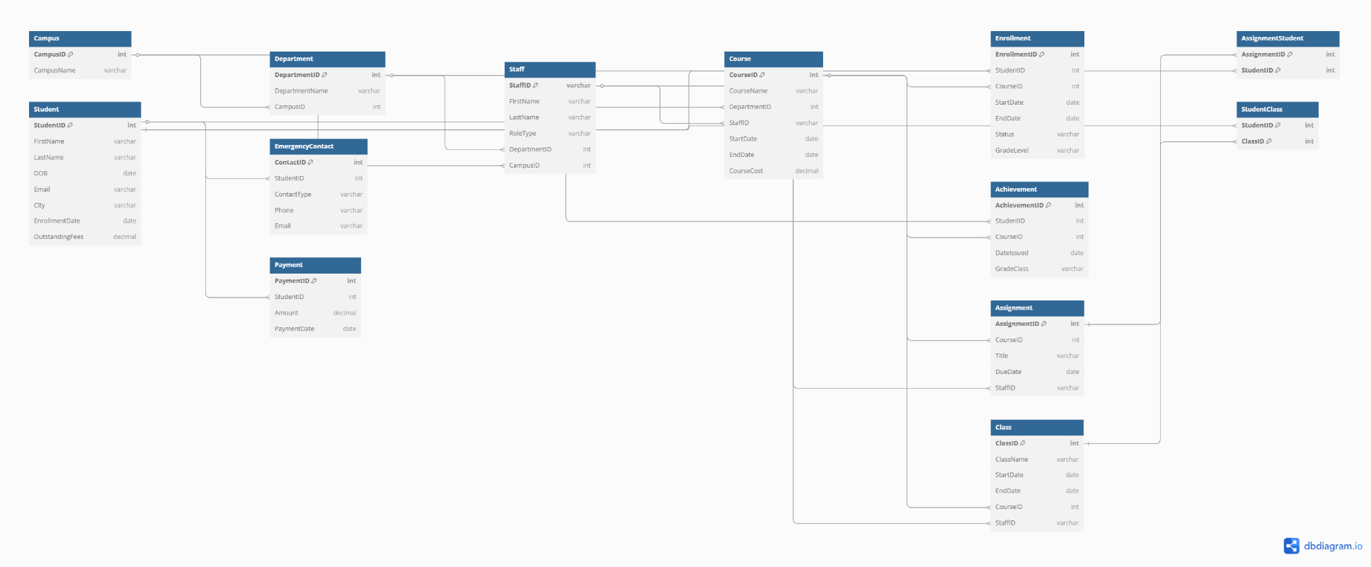

Figure 1Initial ERD Design

## Limitations in the Initial Design

The original ERD lacked flexibility in handling real-world scenarios. Representing all staff responsibilities within a single Role Type field made it impossible to assign multiple roles to a single user. The Course table contained both static metadata and delivery-specific attributes, breaching normalization rules. Ambiguous table names, such as Student Class and Assignment Student, made it difficult to understand their function within the system. Emergency contact information was limited to a one-to-one relationship, which does not reflect the reality of many students having multiple guardians or contacts. Furthermore, the Achievement table combined certificate and grading data, making future reporting or analytics more complex.

## Enhancements in the Final ERD

The revised ERD addressed earlier limitations through specific structural improvements. The introduction of RoleType and StaffRole tables enabled a many-to-many relationship, allowing flexible assignment of roles to staff members. A new entity, CourseOffering, was created to separate delivery-specific details such as StartDate, EndDate, and Fee from the general course metadata. Tables such as StudentClass and AssignmentStudent were renamed to ClassEnrollment and StudentSubmission, respectively, improving clarity. The EmergencyContact table was restructured to allow multiple contacts per student, and Achievement was renamed to Certificate to clarify its function.These revisions improved the structure's integrity, ensured compliance with third normal form (3NF), and supported future expansion, such as access permissions or analytics dashboards (Connolly and Begg, 2021)

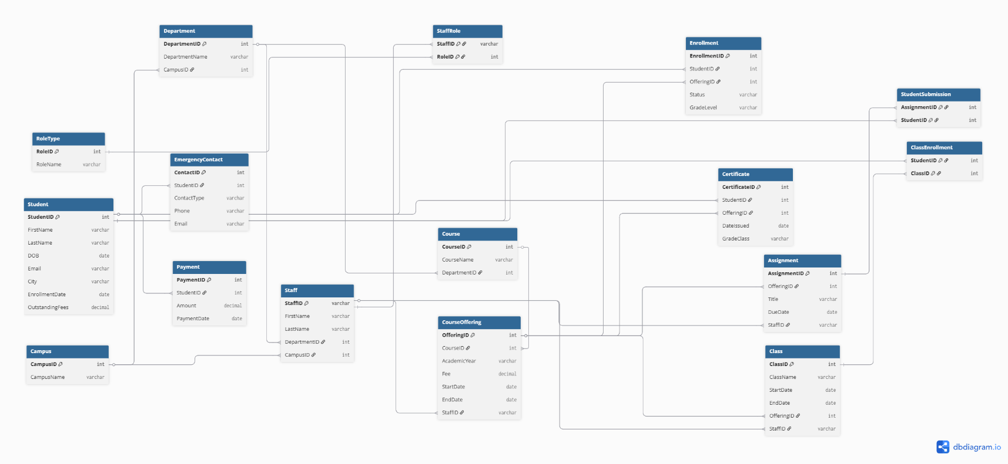

Figure 2: Final ERD Design

## Reflection on the ERD Design Process

The ERD redesign revealed structural limitations in the original plan and allowed deeper engagement with relational modelling principles (Rob & Coronel, 2018). This adjustment phase clarified the importance of normalization and futureproofing in system architecture.

# 2.0 Database Implementation and Data Manipulation

A database is a structured system used to manage and store data efficiently for retrieval and updates. In this project, the SQLite3 platform was used to translate the enhanced ERD into physical tables for Leaf Village Training Ltd. Each table was created using SQL commands and structured according to entity relationships and normalization principles (Connolly & Begg, 2019; Elmasri & Navathe, 2021).

The final schema consisted of 16 interrelated tables. To maintain clarity and normalization, tables were grouped into logical modules such as users, academics, administrative operations, and supporting infrastructure. SQL CREATE TABLE statements and selected INSERT, UPDATE, ALTER, and TRIGGER queries were applied.

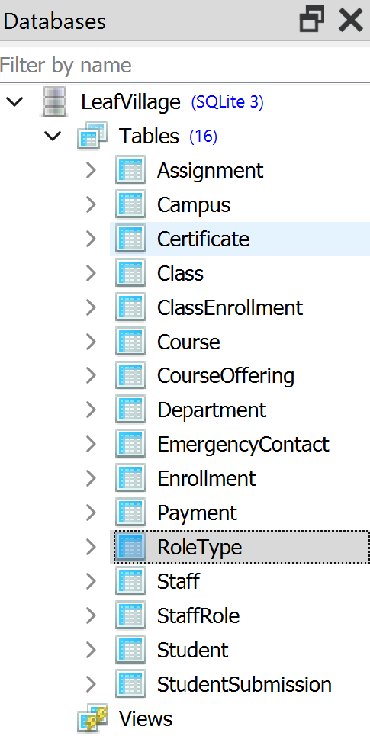

Figure 3Complete Table Structure

## Data Insertion

Once all tables were created, sample records were added using INSERT INTO. These included diverse student profiles, staff members across campuses, and varied course offerings.

# Table Creation and Structure Overview

### Student & Emergency Contact Tables:

The student table holds personal and academic information. EmergencyContact allows multiple contact entries per student (1:N relationship), enhancing data realism and flexibility.

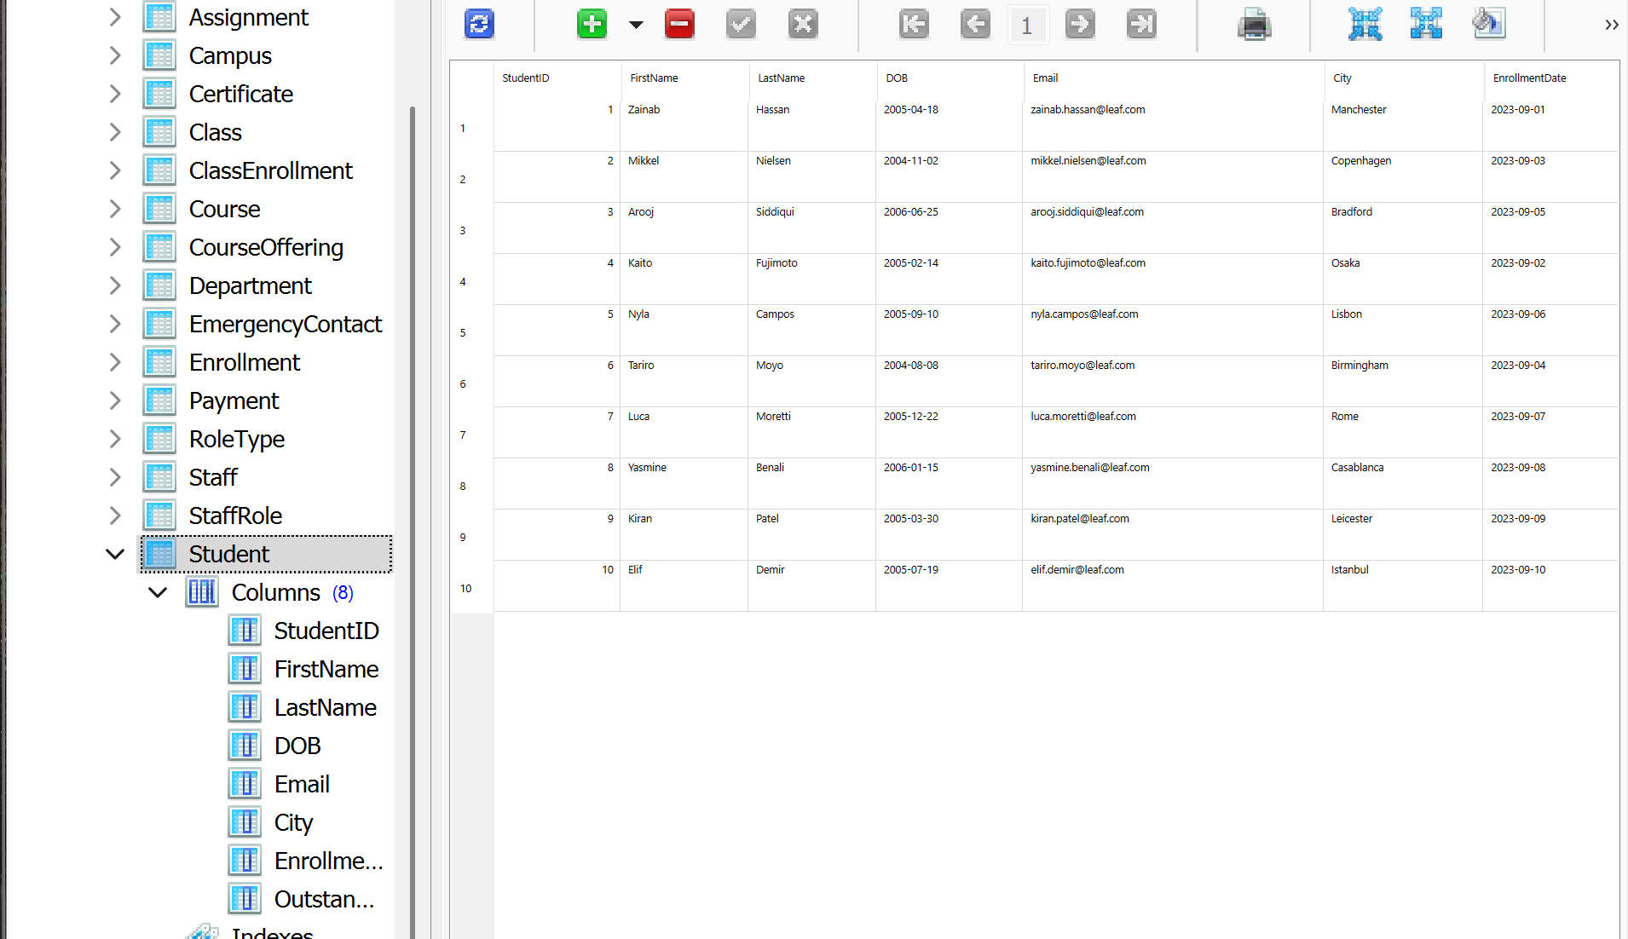

Figure 4:student_table

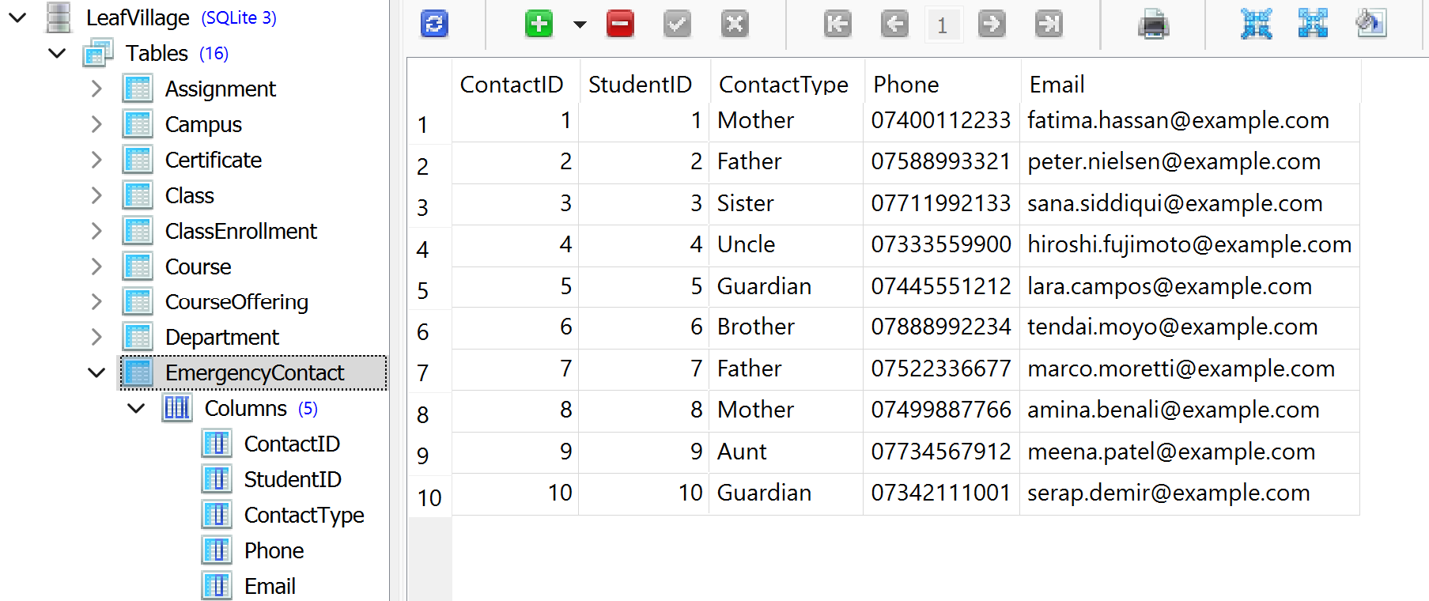

Figure 5:emergency_contact

### Staff, RoleType & StaffRole:

To implement flexible role management, a many-to-many structure was applied. *StaffRole* functions as a junction table between *Staff* and *RoleType*, supporting role combinations like 'Instructor' and 'Examiner' **(**Batini, Ceri and Navathe, 2019).

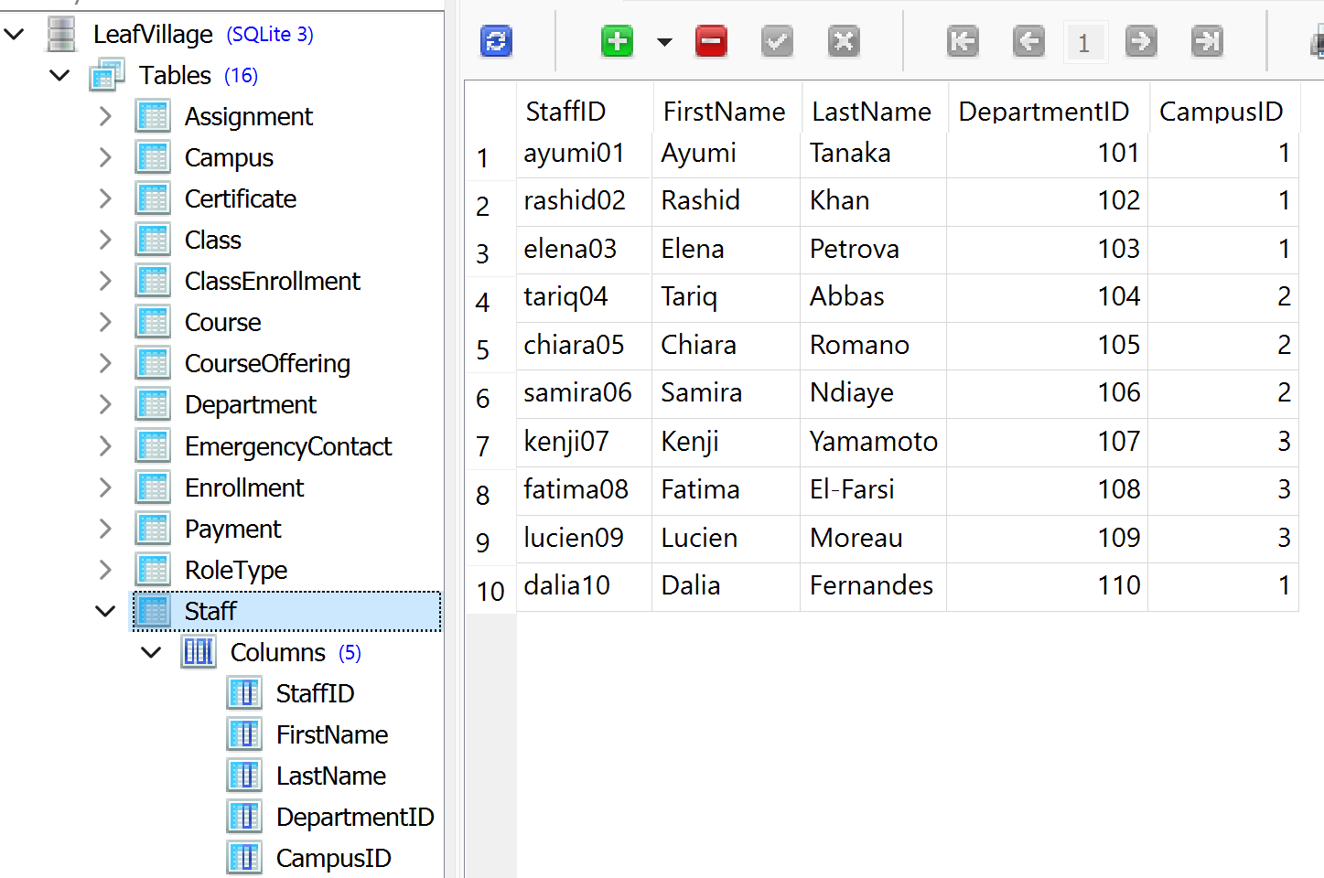

Figure 6: staff table

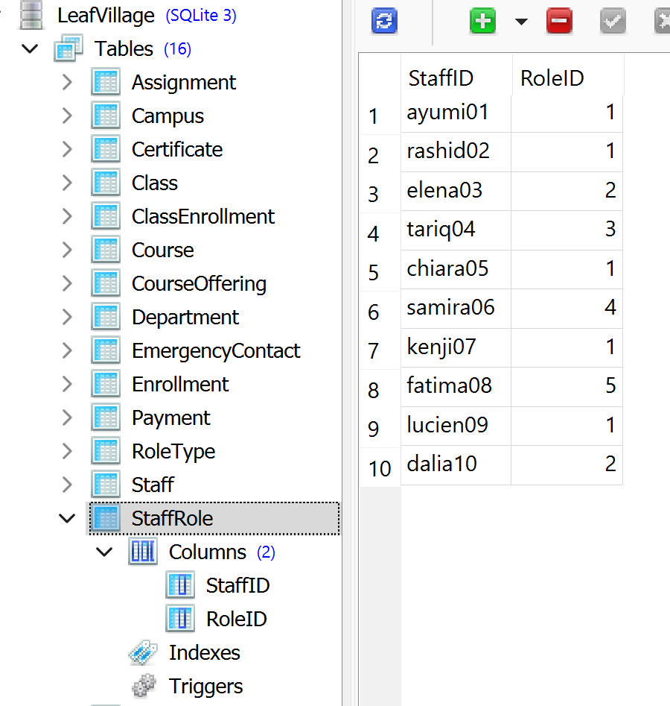

Figure 7:staffrole_table

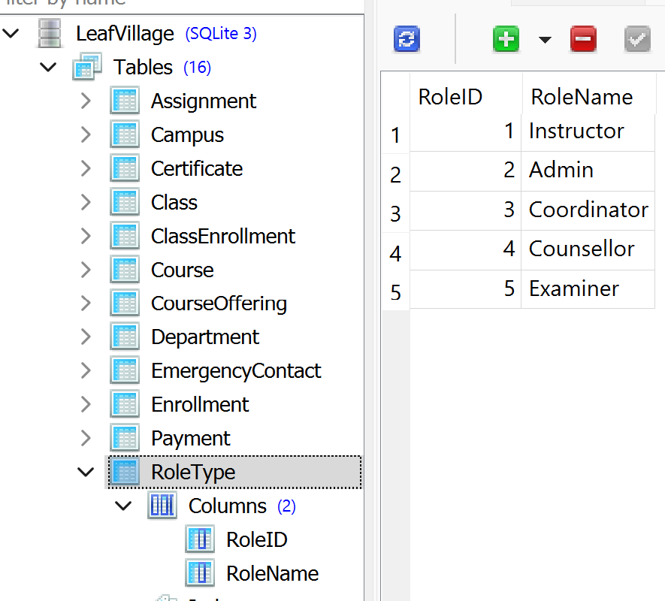

Figure 8:roletype_table

### Course & CourseOffering:

The Course table stores core course details. CourseOffering separates session-based data (fee, dates) from metadata, in alignment with third normal form (3NF). This structure also supports managing new courses expected to launch in 2025–2026 (Jukic et al., 2019)

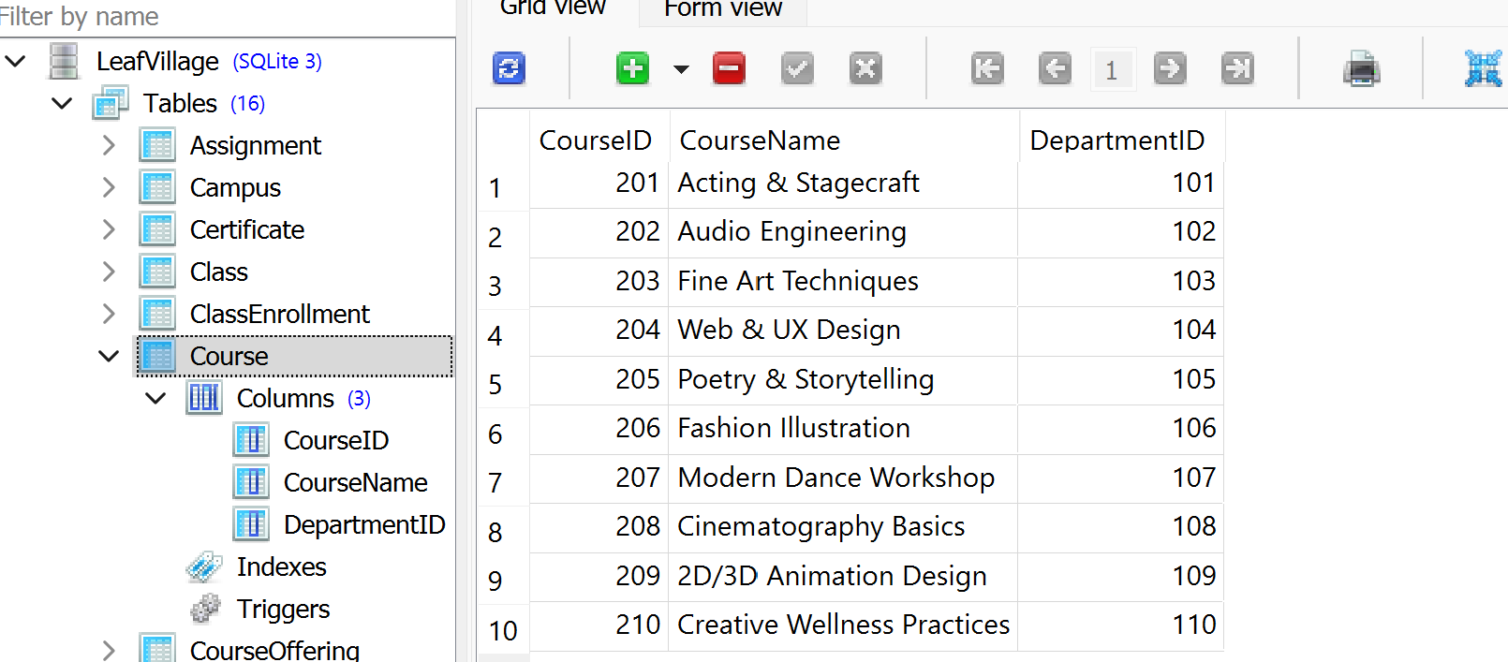

Figure 9:course_table

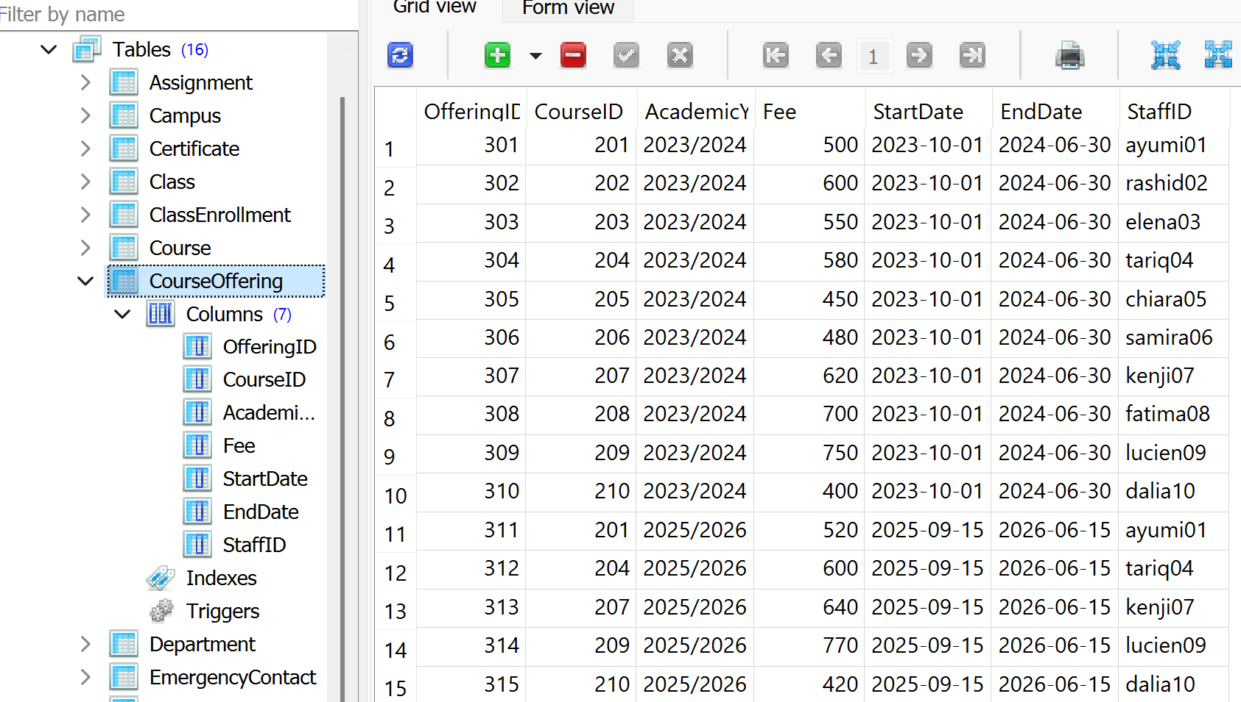

Figure 10:courseoffering_table

### Class & ClassEnrollment:

Each Class is tied to a specific course offering and faculty member. The *ClassEnrollment* table manages many-to-many student-class relationships (Mannino, 2020).

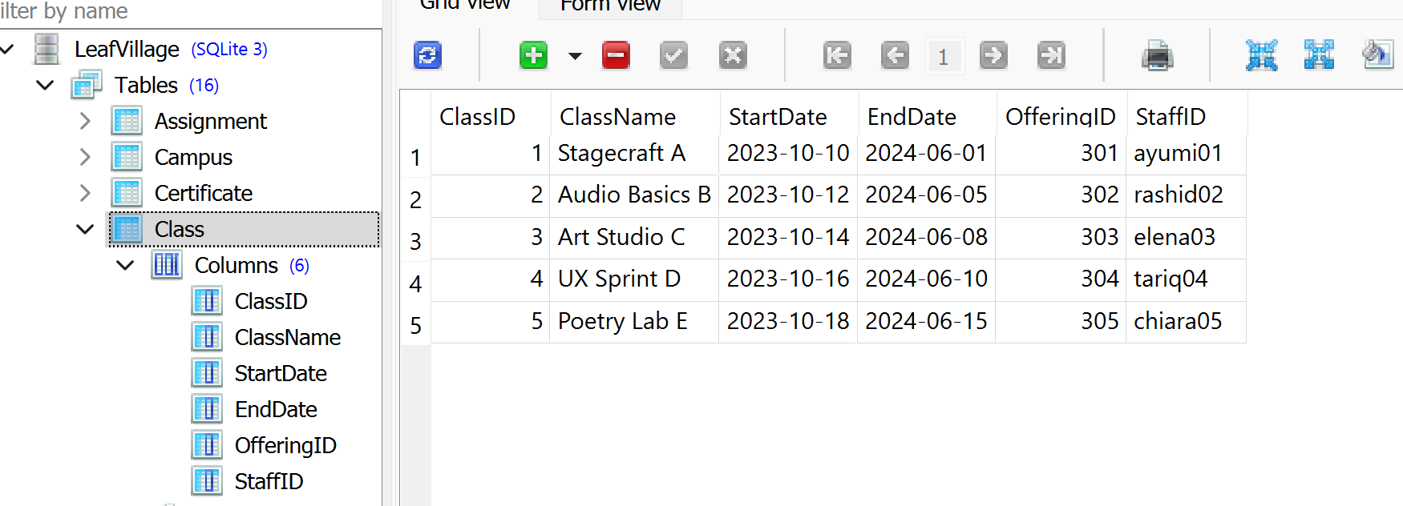

Figure 11:class_table

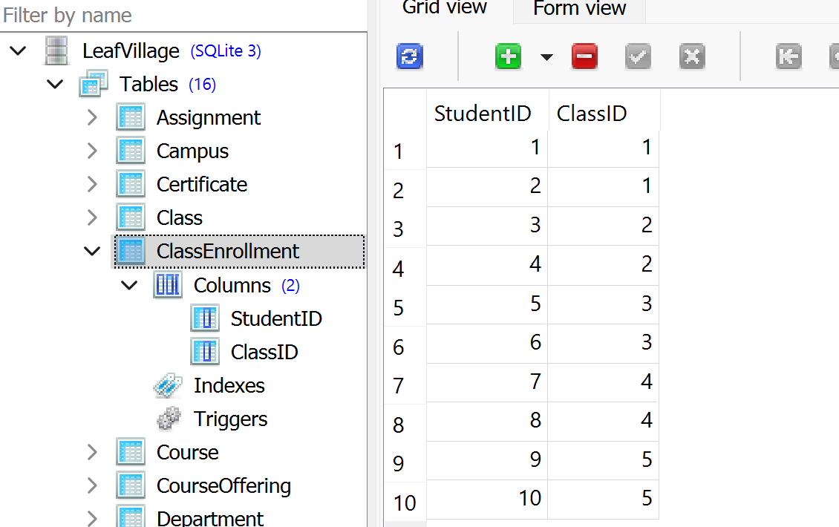

Figure 12:class enrollment_table

### Assignment & Student Submission:

Assignments are linked to offerings and evaluated via StudentSubmission, allowing tracking of student progress and deliverables, inspired by Microsoft Teams, where tasks appear in channels but are submitted through dedicated portals (Microsoft, 2023).

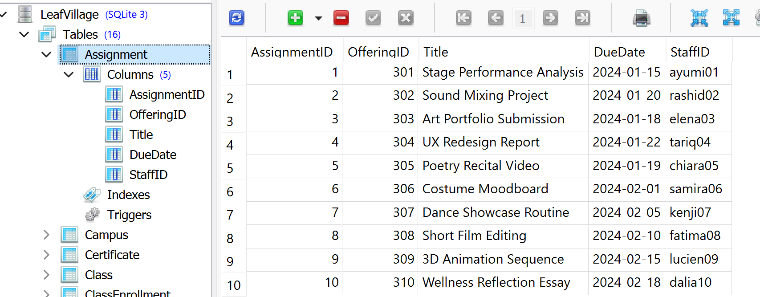

Figure 13:assignment_table

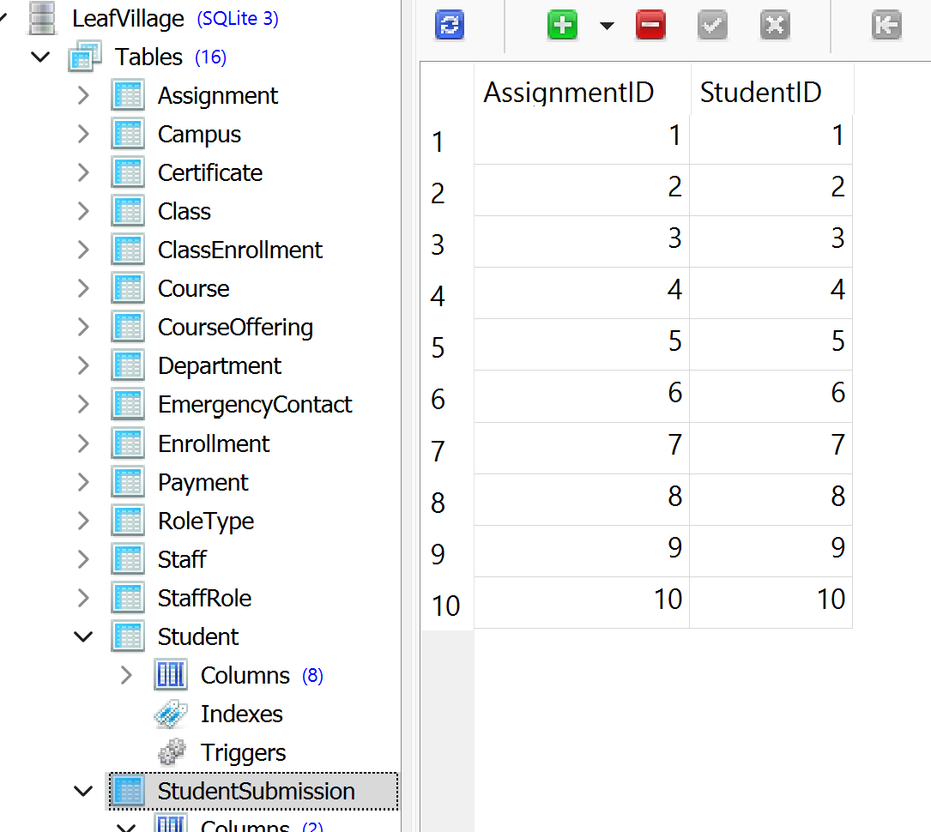

Figure 14:studentsubmission_table

### Enrollment & Payment:

Enrollment captures course participation, status (Pending, Approved, Completed), and grading level. The default value of 'Pending' was added to the Status field using ALTER TABLE. Payment logs student fee transactions, with triggers updating enrollment status based on payments.

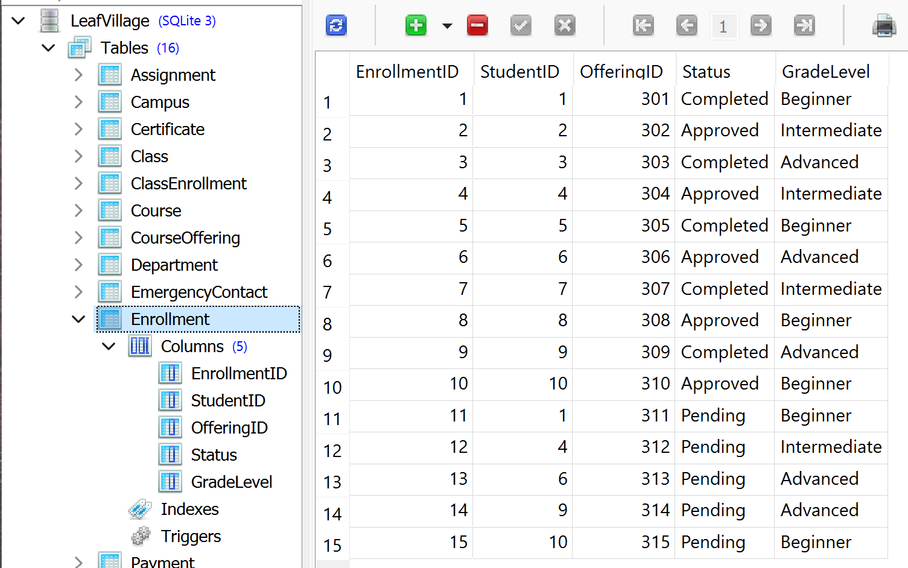

Figure 15:enrollment_table

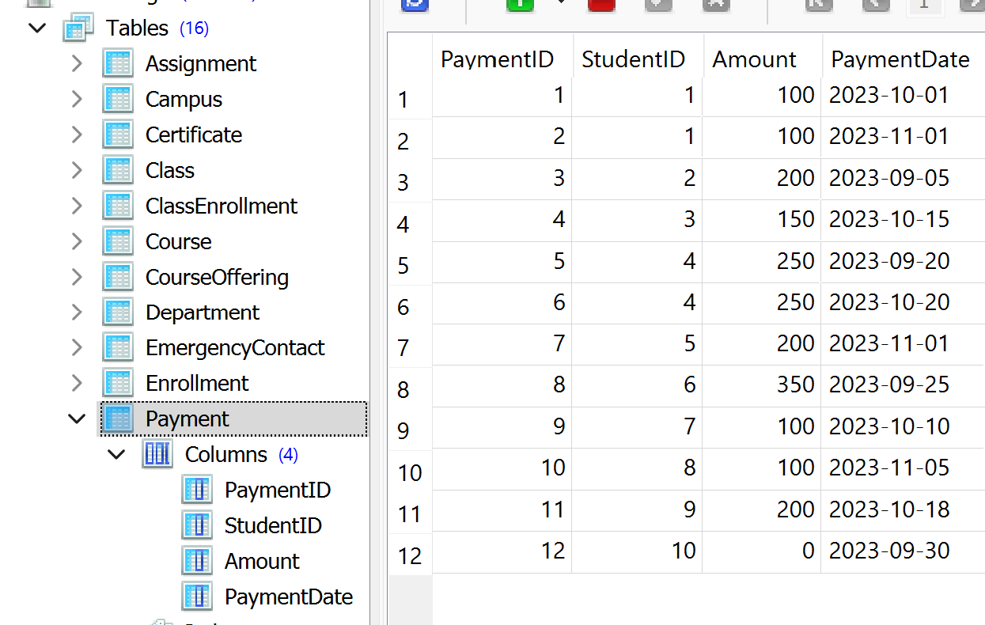

Figure 16:payment_table

### Certificate:

Issued post-course, the Certificate table (originally named Achievement) stores issuance dates and grades. Renaming and column addition (GradeClass) were handled using ALTER TABLE commands.

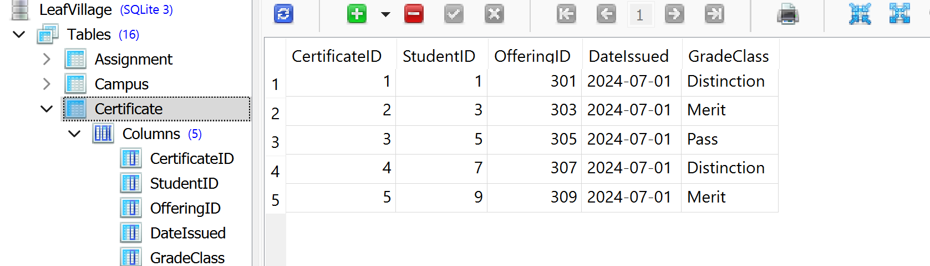

Figure 17:certificate_table

### Campus & Department:

To reflect Leaf Village’s organizational structure, Campus and Department tables categorize where staff and courses belong geographically and academically. A Location column was added to Campus to improve data specificity.

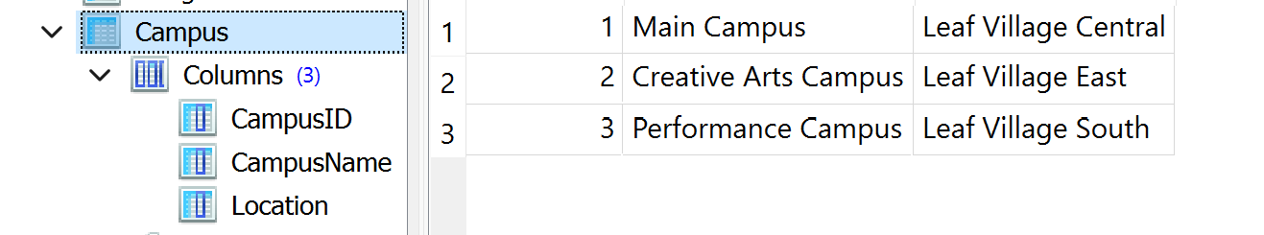

Figure 18:campus table

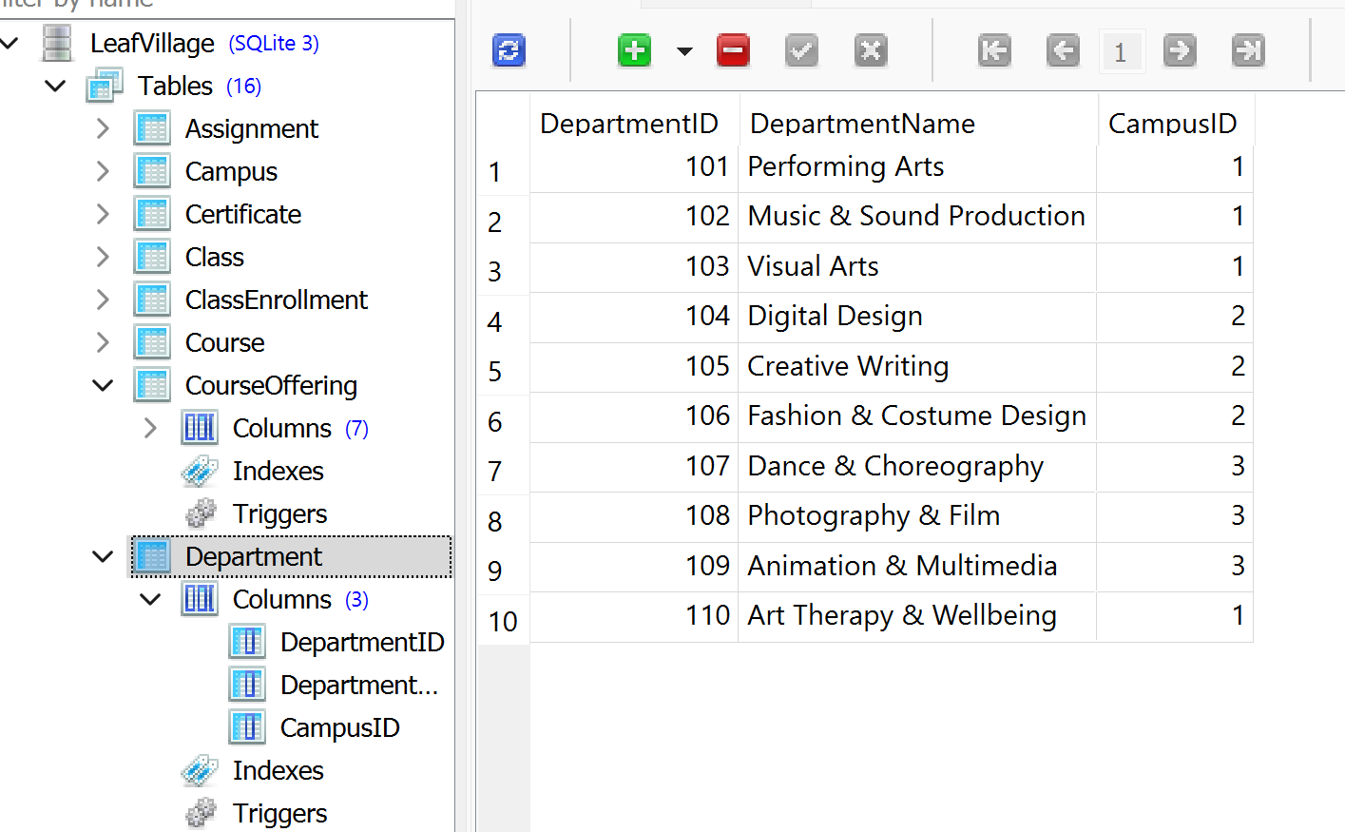

Figure 19: department_table

### Pending View:

Two SQL views were implemented to simplify reporting. PendingStudents lists learners with pending enrollments using a JOIN and status filter, while View_AllOfferedCourses aggregates upcoming course data, including instructor and fees. These support efficient administration and align with SQL reporting practices (Colonel & Morris, 2019).

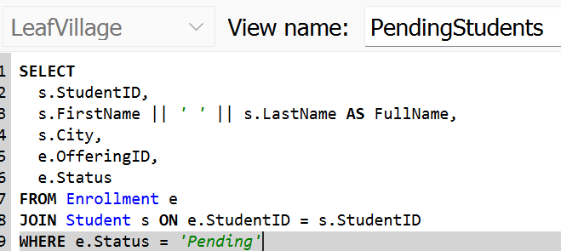

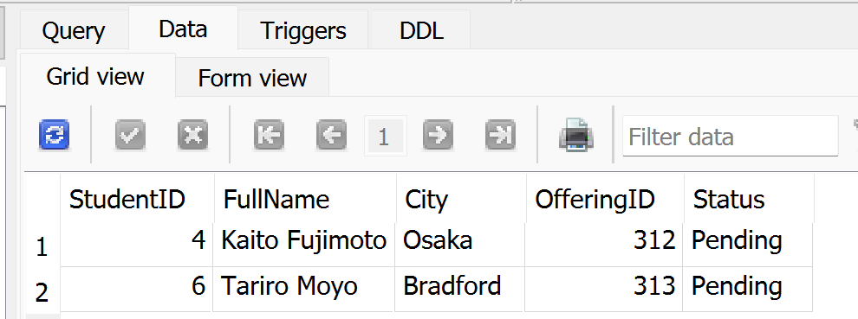

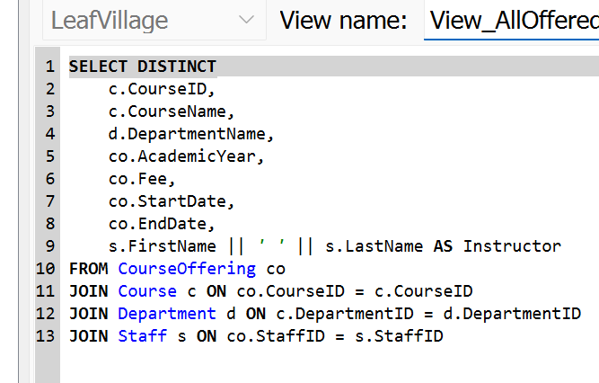



## Constraints and Validation

During testing, it was observed that StudentID 1 appeared in multiple enrollments, including offerings 301 and 311. While valid for different courses, this raised concerns about the possibility of duplicate enrollments in the *same* course offering.

To enforce data integrity, a composite UNIQUE constraint was implemented using a SQL index, following relational schema best practices (Connolly & Begg, 2019). This ensures that a student cannot be enrolled more than once in the same offering.

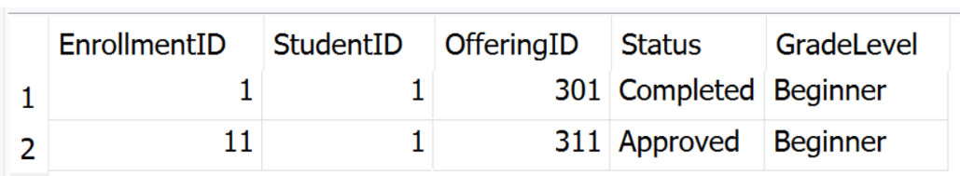

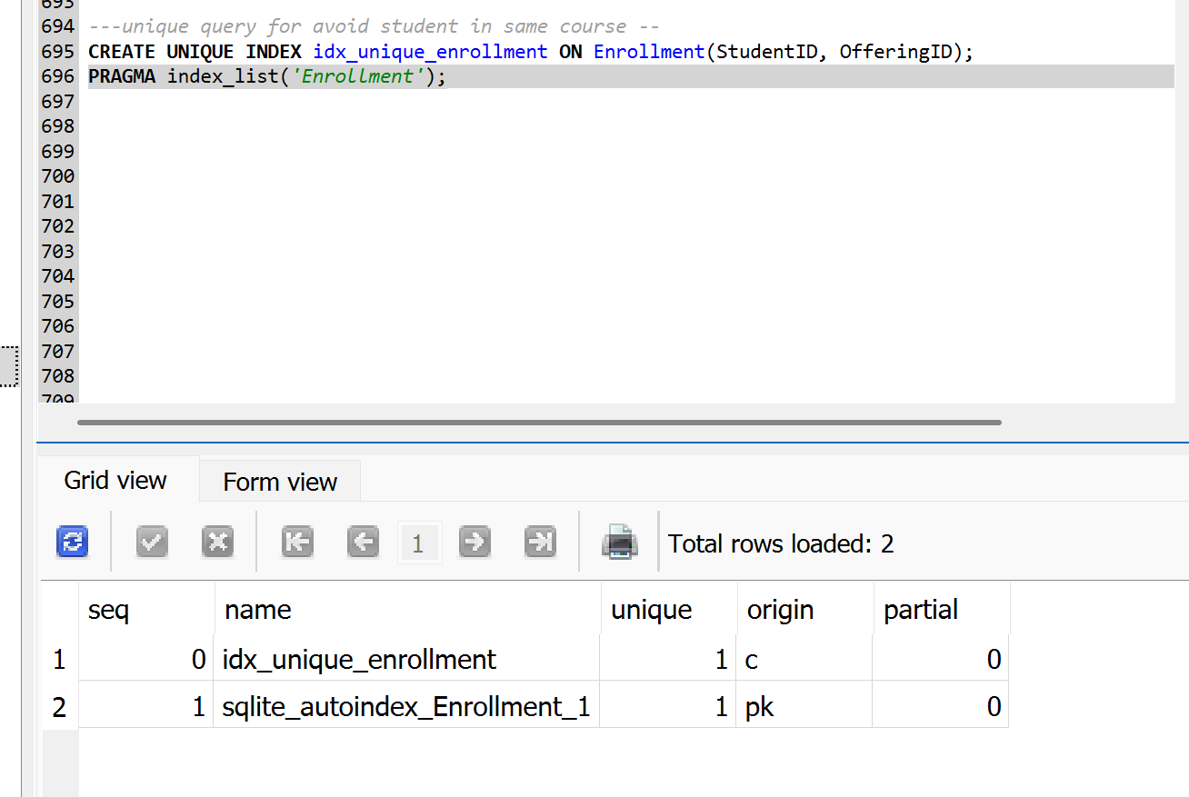

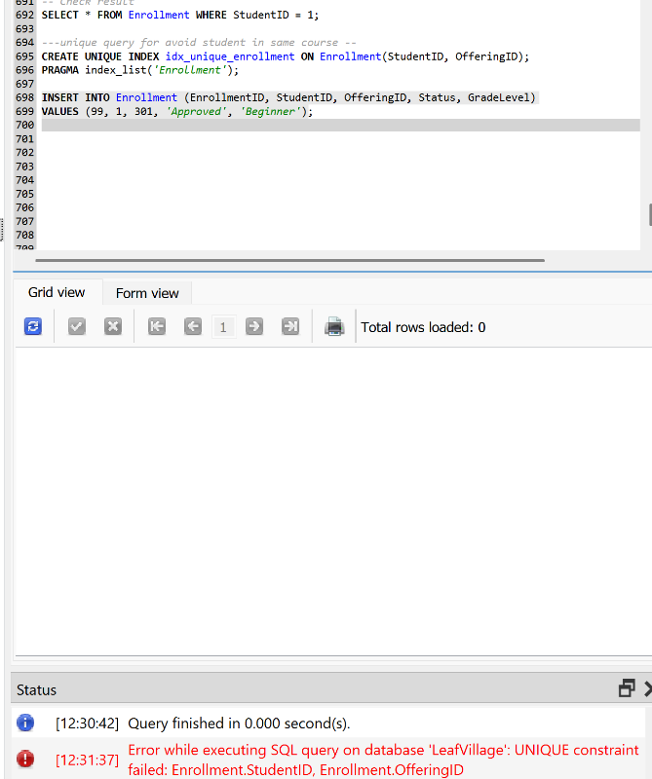

Figure 20: unique_id_test_1

## Trigger and Automation

Triggers ensured that related data fields were automatically updated after specific actions. This reduced manual errors and maintained referential integrity.

The first trigger updated the Enrollment status to 'Completed' automatically when a certificate was issued. This ensured that once a student earned a certificate, their course record reflected successful completion without manual input.

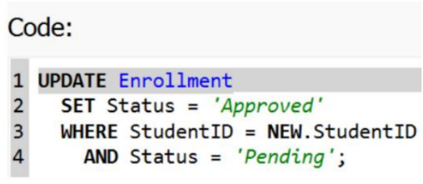

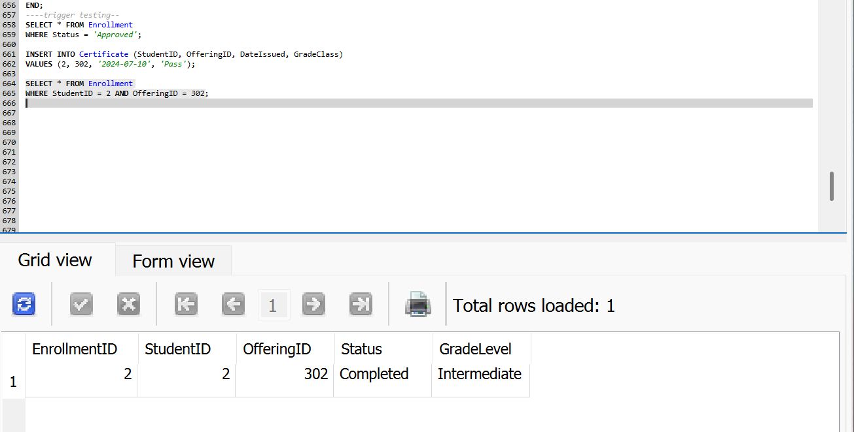

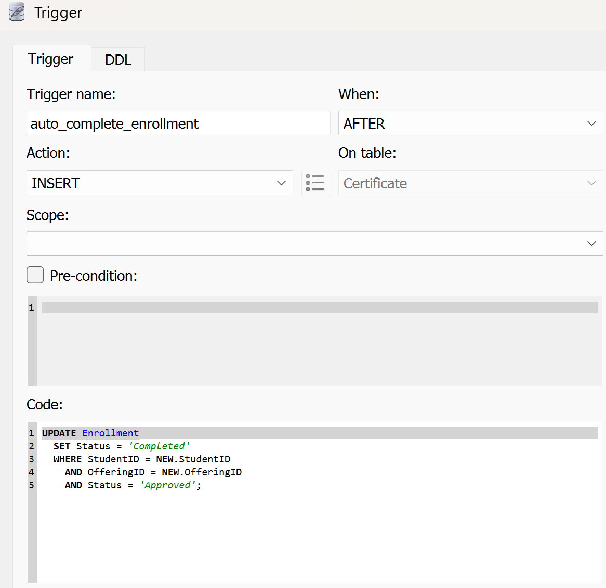

Figure 21 Trigger for certification

The second trigger changed the enrollment status from 'Pending' to 'Approved' after a student made a payment, helping automate administrative processes.

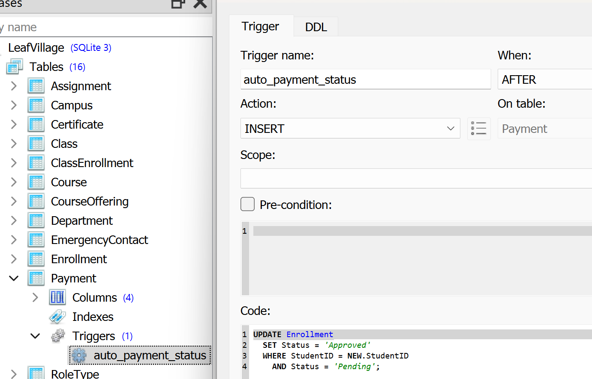

Figure 22 : trigger for enrollment

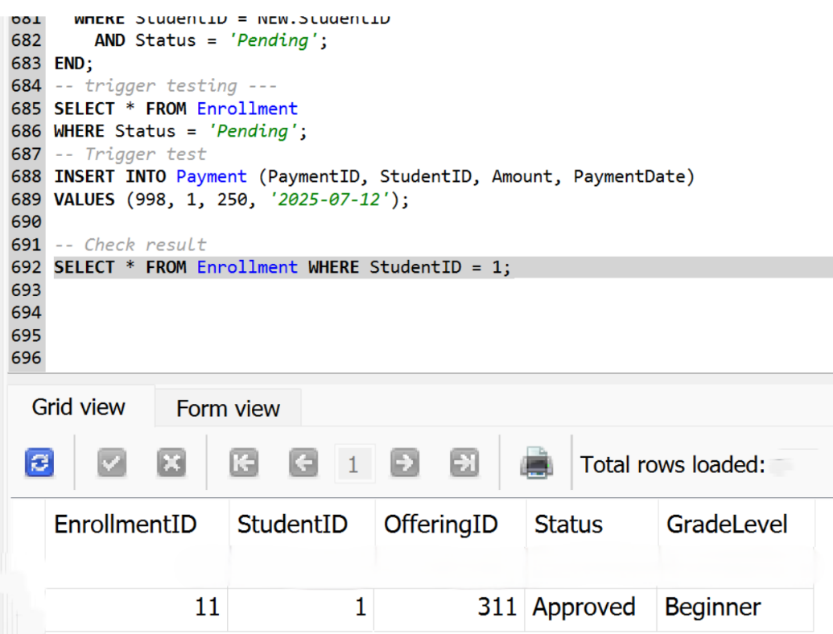

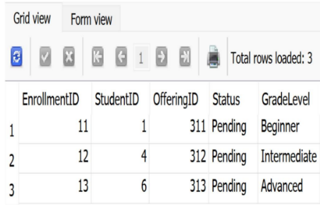

Figure 23 : trigger2 testing

### Reflection on Implementation

Several enhancements were made during implementation. Tables were renamed (e.g., StudentClass to ClassEnrollment) for semantic clarity. Default values like 'Pending' in the Enrollment table simplify data entry. The Achievement table was renamed to Certificate, and a GradeClass column was added for clarity in evaluation. The Campus table was improved with a Location field for more precise administrative grouping. These corrections addressed earlier inefficiencies and reinforced the importance of data normalization, relational integrity, and automation in real-world systems (Silberschatz et al., 2020).

# 3.0 SQL Query Analysis and Business Insights

According to Silberschatz et al. (2020), structured query language (SQL) is essential for managing relational data and generating insights that support operational and strategic decisions. In the context of Leaf Village Training Ltd., SQL queries were used to extract meaningful patterns from student and course data.

This section builds on the implementation phase by showcasing analytical queries that identified inactive learners, monitored enrolment trends, assessed faculty load, and calculated revenue. Each query was tailored to stakeholder needs, demonstrating SQL’s real-world value in improving service quality and enabling data-driven planning.

## Show Names of Students and Their Enrolled Courses

To identify which students are actively participating in the academic program, a multi-table join was applied across Enrollment, Student, CourseOffering, and Course tables. The query focuses only on student' full names and their associated course names, omitting other details for clarity and relevance.

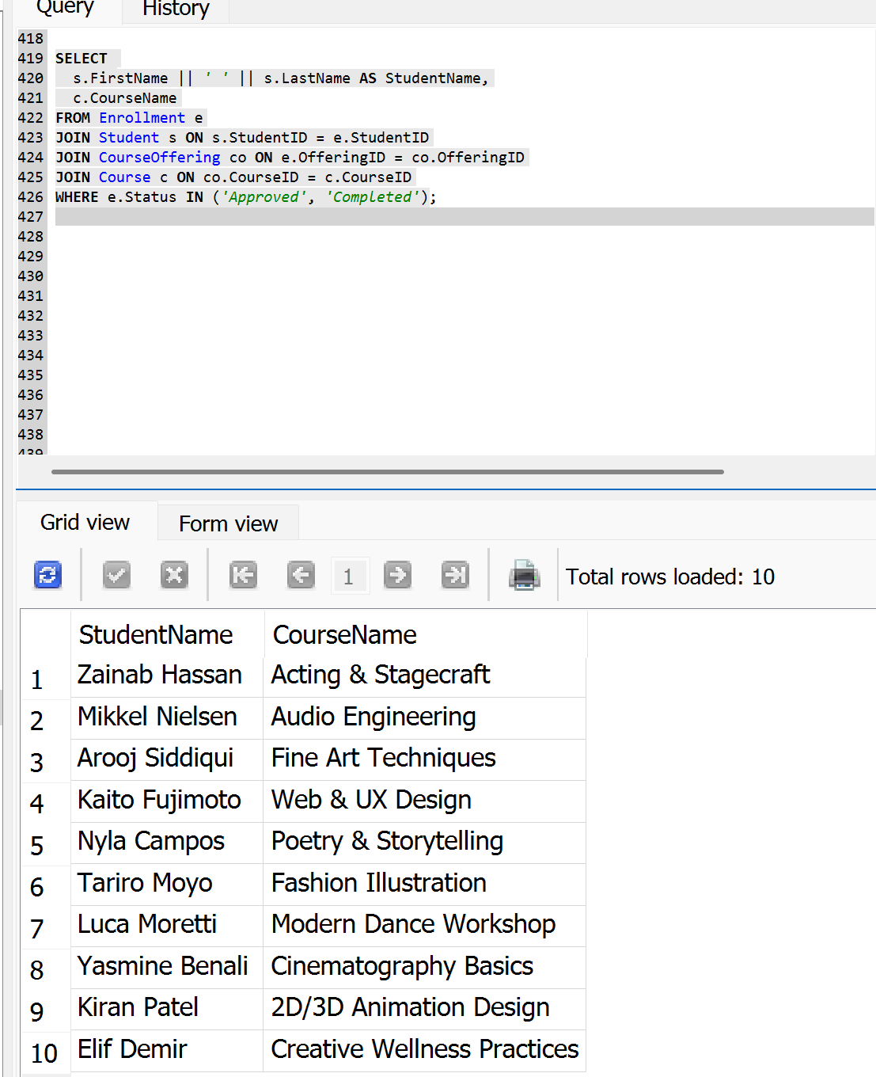

Figure 24: Student and course

This output enabled management to quickly verify active student-course relationships and assess course popularity for scheduling or communication purposes.

## Identify Students Who Never Enrolled

To support outreach initiatives, Leaf Village management needed to identify students who had registered but had not yet enrolled in any course. This was achieved by using a LEFT JOIN between the Student and Enrollment tables, followed by a WHERE clause that filtered for NULL values in Enrollment.StudentID.

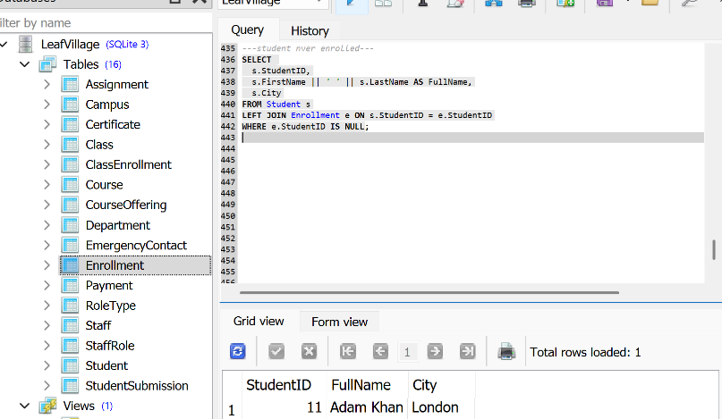

Figure 25: student who never enrolls

The query revealed inactive students who had no course participation, enabling targeted engagement strategies to improve overall enrolment rates.

## Students Enrolled Between Specific Dates

To monitor student intake trends, a query was developed to extract all students who enrolled within a specific window. This information helps the academic planning team understand peak admission times and better allocate teaching resources

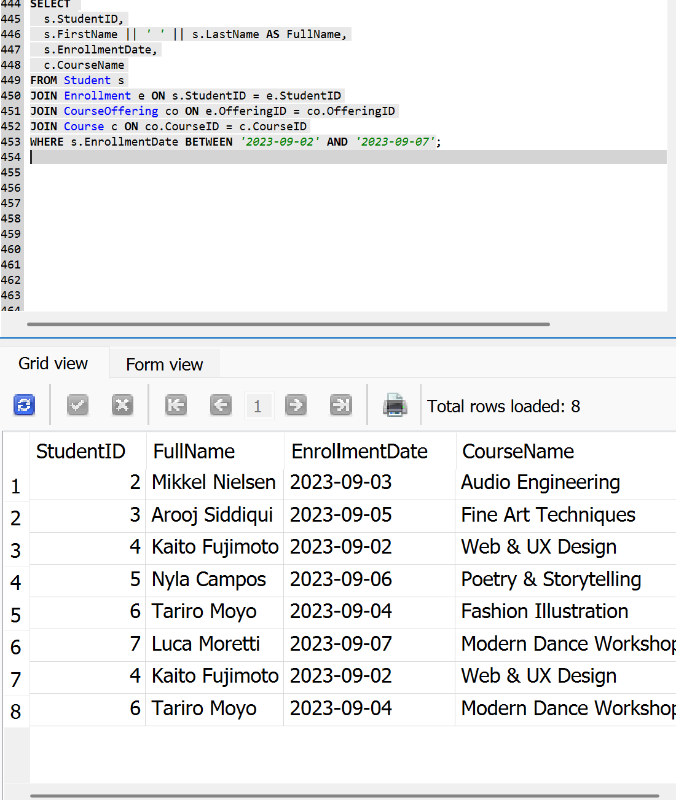

Figure 26: course_student_enroll_date

The result supported planning for timetables, staff availability, and enrolment drives by identifying when most learners join.

## Students Living in the Same City

To support community outreach and localisation efforts, a query was run to identify students residing in the same city. This allowed Leaf Village to design group-based activities, workshops, or travel support more effectively.

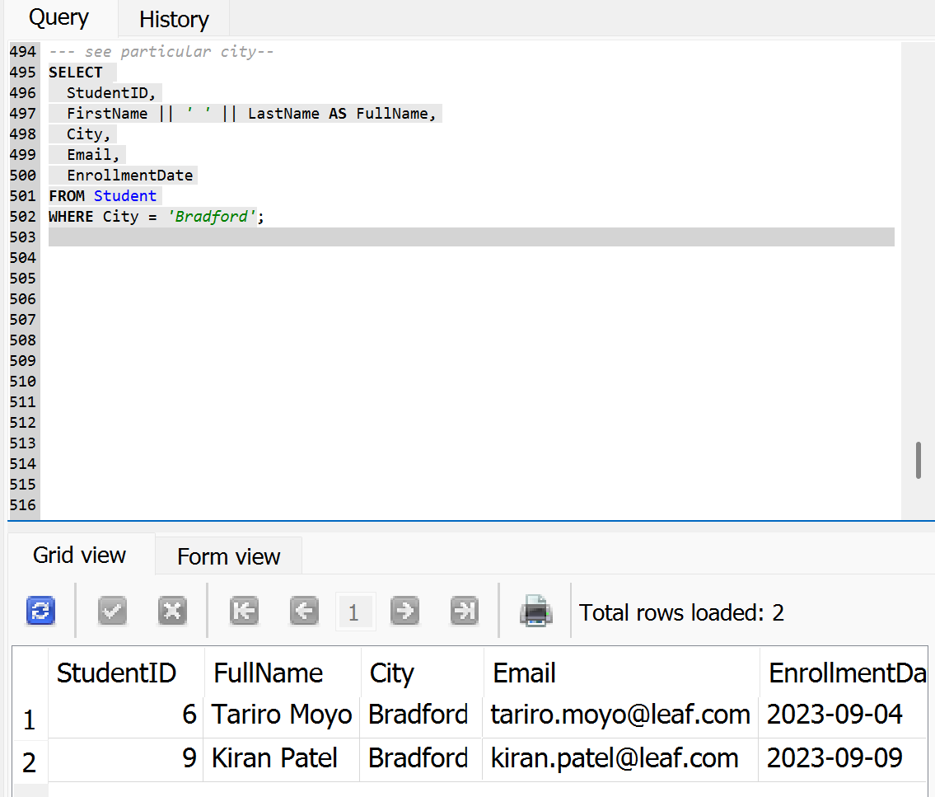

Figure 27: student_in_same_city

In this case, filtering for ‘Bradford’ helped management understand regional concentration and design city-specific academic or support strategies.

## Instructor with the Fewest Students

To ensure fair workload distribution among teaching staff, a query was executed to identify which instructor had the lowest number of student enrollments. This task used aggregation (COUNT), filtering (WHERE), grouping (GROUP BY), and sorting (ORDER BY).

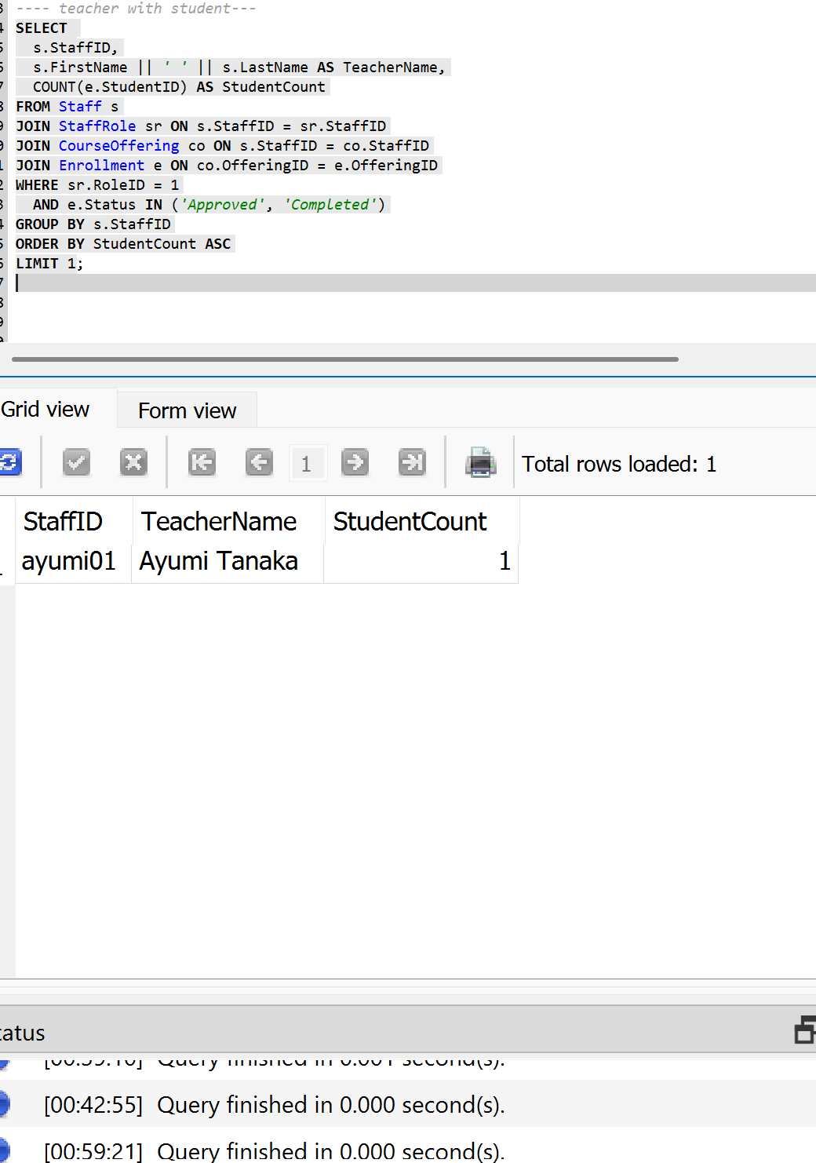

Figure 28: Instructor with a few students

This insight supported balanced faculty planning, ensuring that instructors were neither underutilized nor overburdened, which helped management deploy staff more effectively in future sessions.

Show Each Course and the Number of Enrolled Students

To support data-driven academic planning, a grouped summary of course-wise enrollment was generated. This query applies COUNT and GROUP BY to present the number of learners in each course.

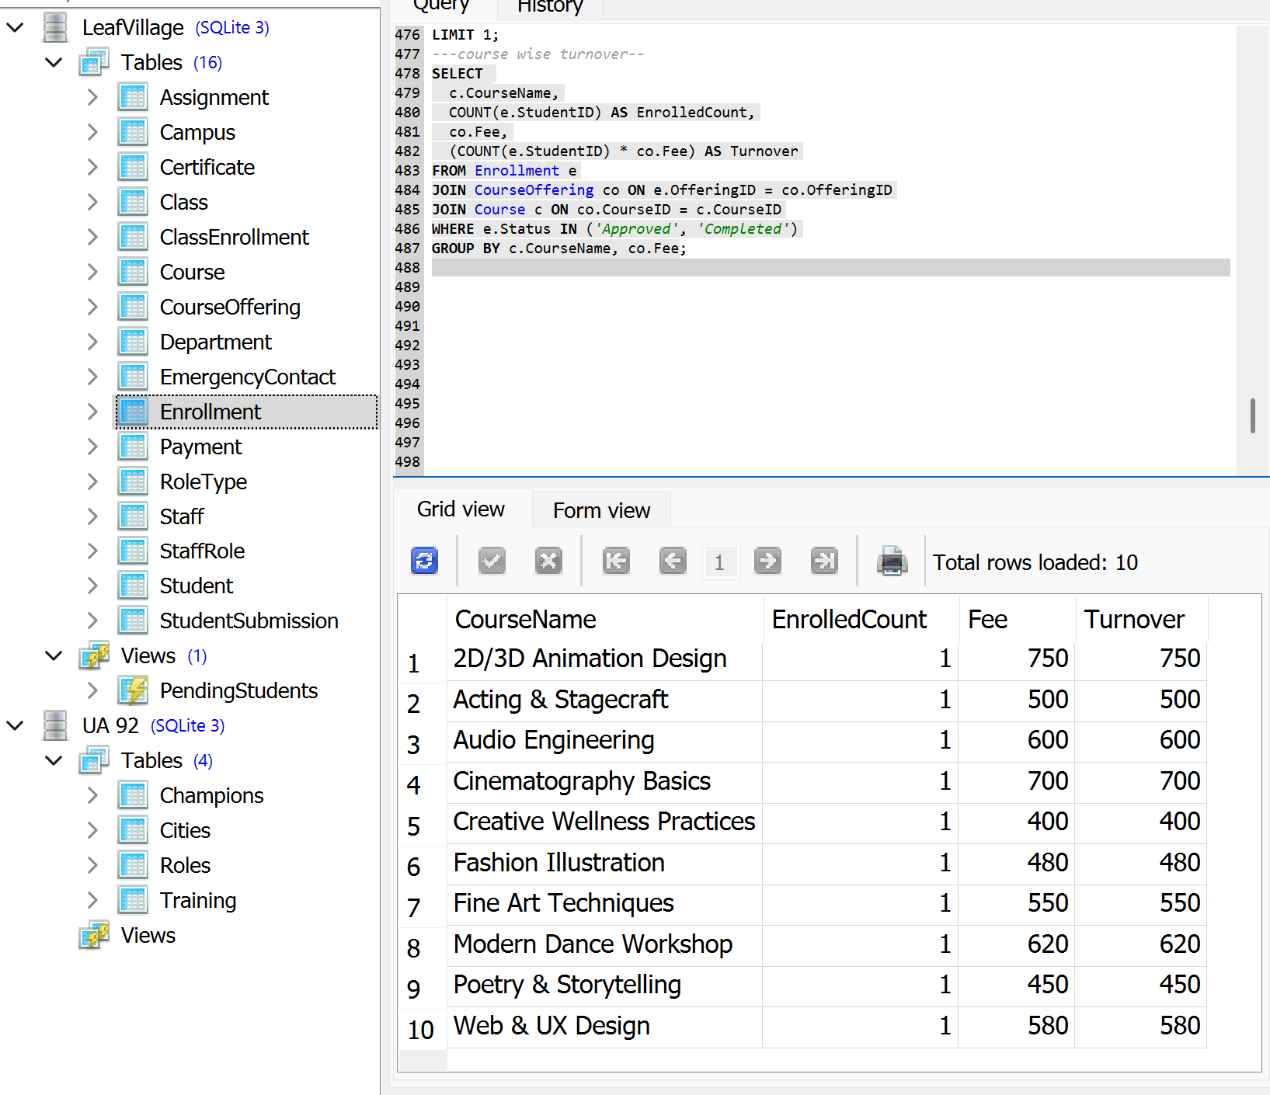

Figure 29: Course-wise turnover

The result helped academic coordinators evaluate course demand and rebalance class sizes where needed, ensuring better resource utilization.

## Total Revenue Calculation

A cumulative view of earnings was derived using the SUM function. This provided a clear overview of income generated from all completed and approved enrollments.

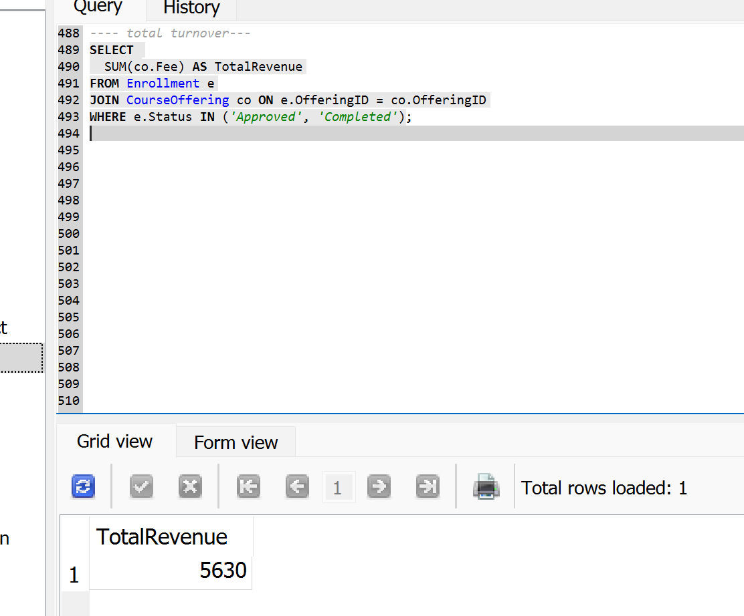

Figure 30: Total revenue

This approach supports higher-level financial dashboards by transforming operational data into strategic value, as recommended in data-intensive education systems (Aljawarneh et al., 2020).

## Certificates Issued Within a Defined Timeframe

To support academic audits and graduation checks, a date-based filter was applied to the Certificate table to retrieve students who received awards between 25th June and 10th July 2024.

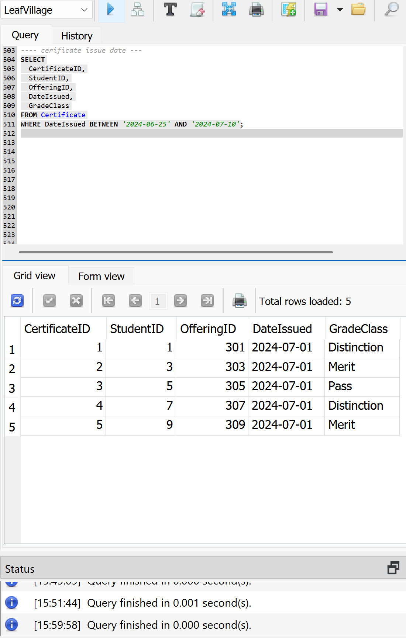

Figure 32: Certificate Issue

This query supports institutional reporting by showing how many learners successfully completed their courses within a target period (Coronel & Morris, 2019).

## Viewing Staff and Their Role Types

To help management understand staff distribution across teaching, administrative, and support functions, a join between Staff, StaffRole, and RoleType was performed. This allowed visibility of multi-role assignments and proper team alignment

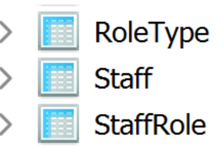

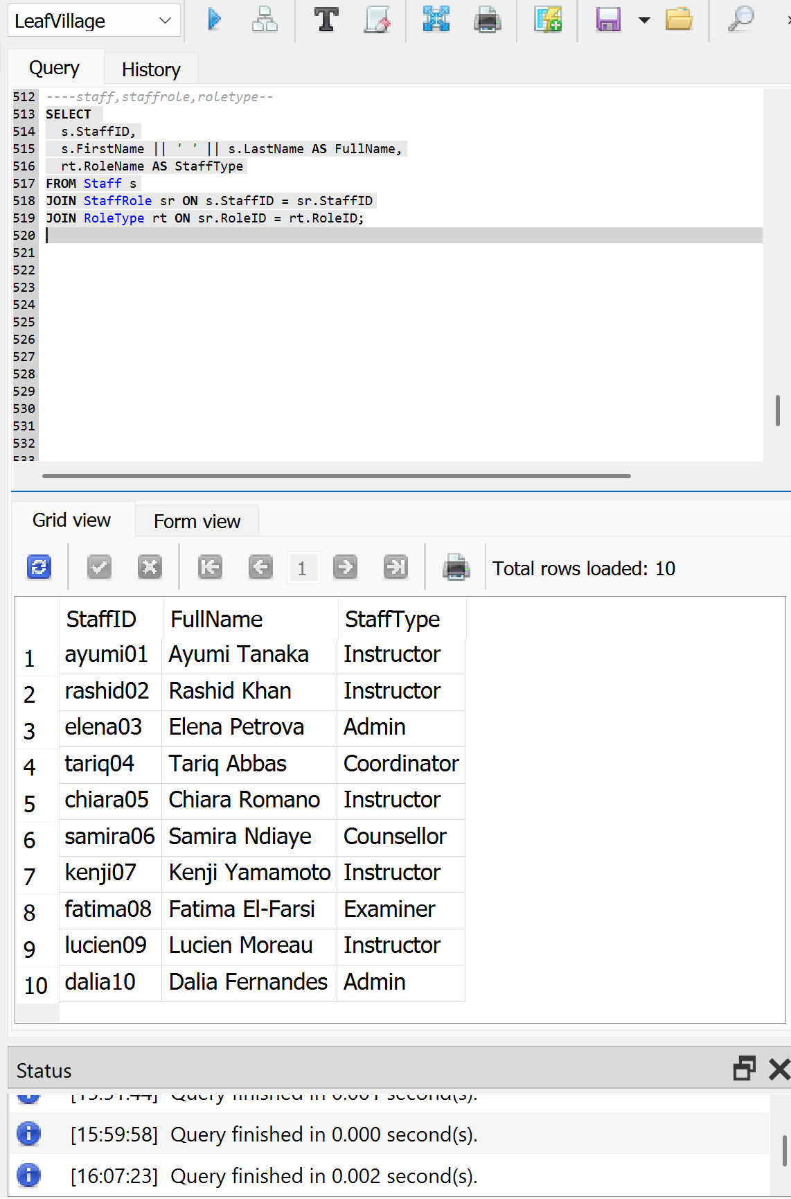

Figure 33 : View staff

The outcome helped validate that every staff member was correctly mapped to their intended responsibilities, supporting transparency and HR planning (Date, 2019).

## Advanced SQL: Identifying Active Students

To highlight engagement, the EXISTS clause identified students who submitted at least one assignment.

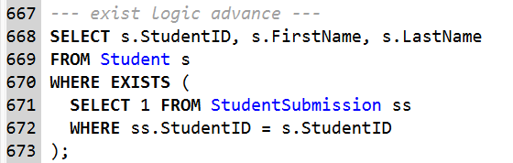

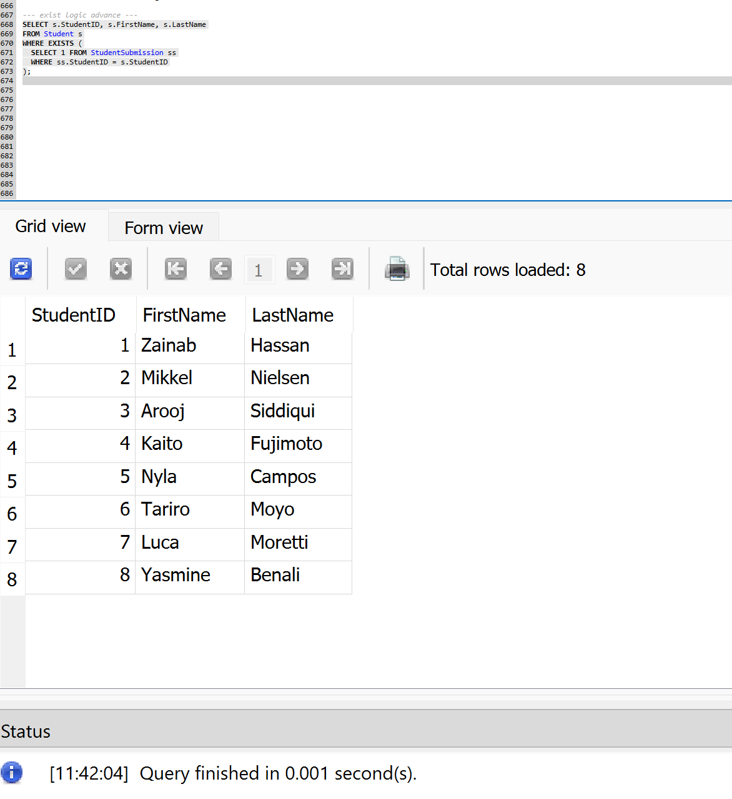

This efficient filter demonstrated advanced querying skills and supported active learner analysis (Silberschatz et al., 2020).

## Virtual Dance Course Management

A new course, *Virtual Dance*, was created with 5 students and later fully removed using INSERT and DELETE commands across related tables.

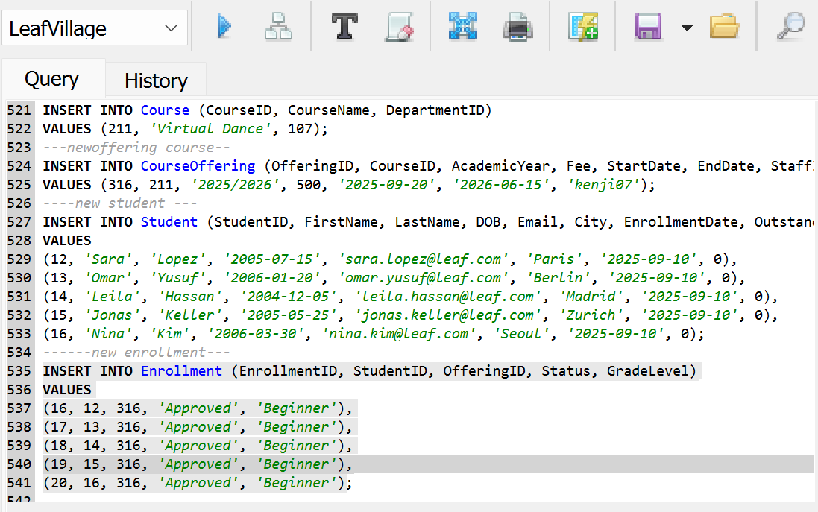

Figure 34 New course and students



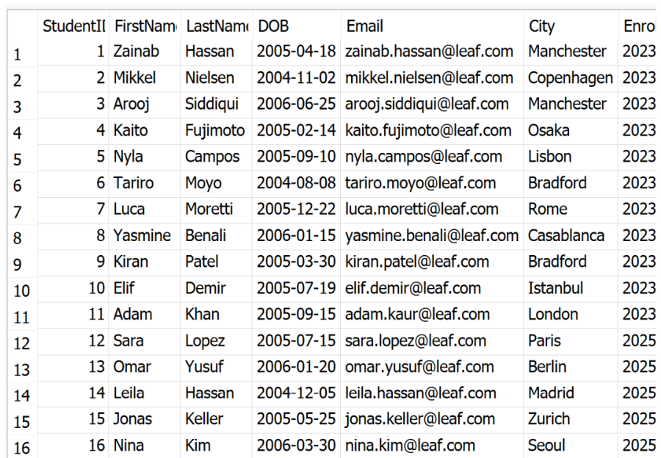

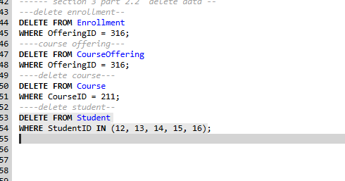

Figure 36 : Delete query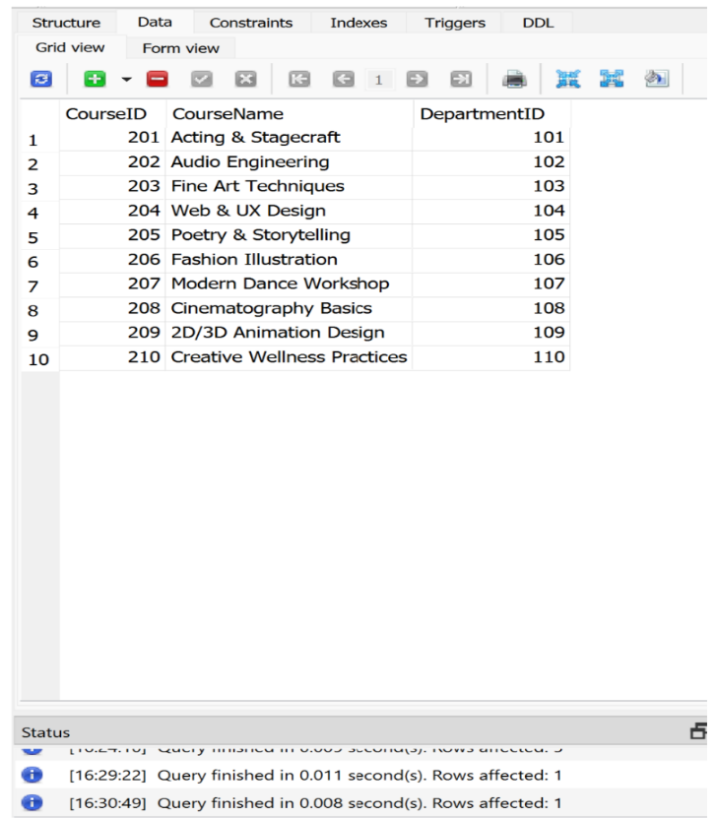

Figure 37: courses after delete

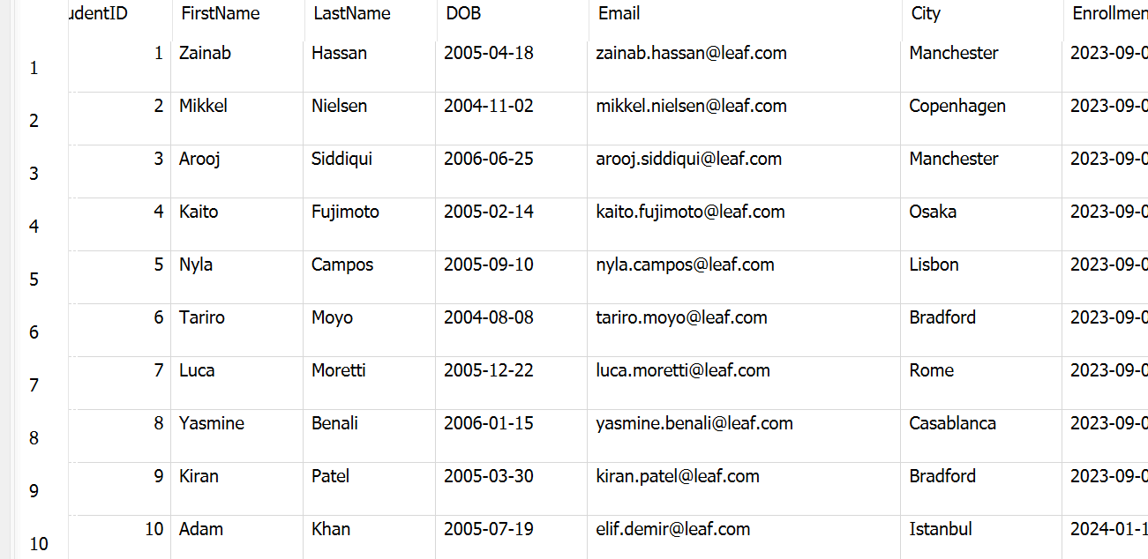

Figure 38 : Students

## Course Deletion with Linked Data

The “Cinematography Basics” course (ID 208) was fully deleted, along with all linked records, using cascading SQL queries. This maintained referential integrity, as recommended by Elmasri & Navathe (2021).



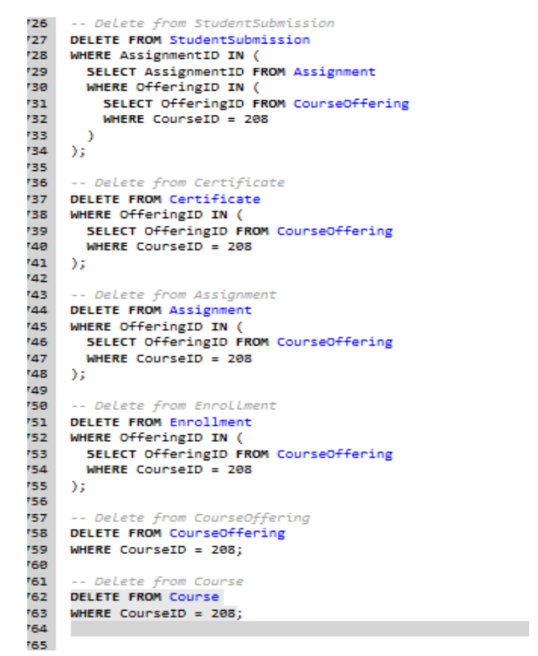



## Deleting a Specific Student Record

To meet the deletion requirement, a student named *Adam* (StudentID = 11) was added and later removed from the system.

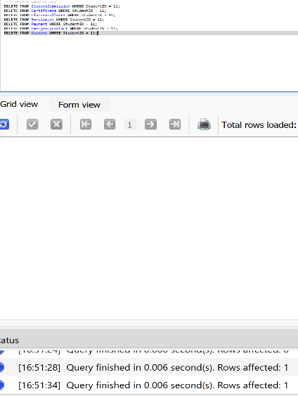

Figure 39: Adam record deletes

## Deleting 'Creative' Courses:

To ensure compliance with the deletion task, courses with 'creative' in their name (e.g., *Creative Wellness Practices*) were removed using a multi-step SQL process to prevent integrity errors, showcasing sound database management practices (Date, 2019).

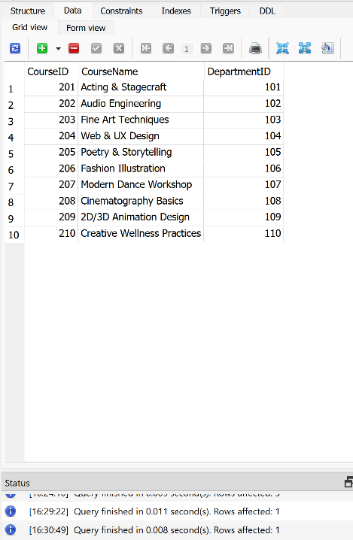

Figure 40: Before delete

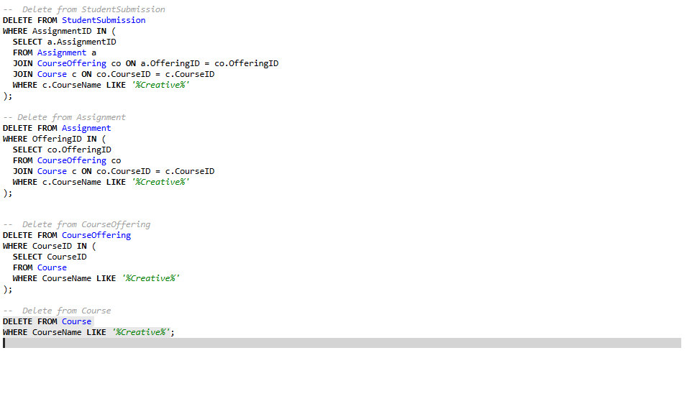

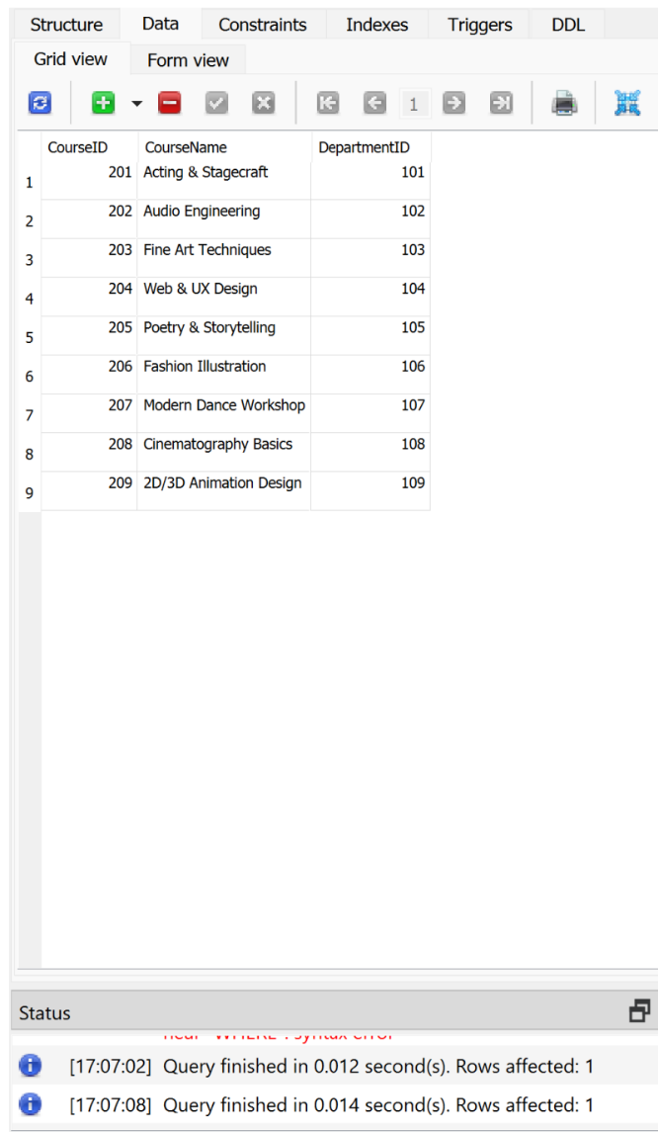

Figure 41: After deleting

## Update Emergency Contact Information

As part of the data correction tasks, an update query was used to modify a student's emergency contact information. This task aligns with data maintenance practices, ensuring records remain current and accurate. For StudentID 9, the phone number in the EmergencyContact table was revised using an UPDATE statement.



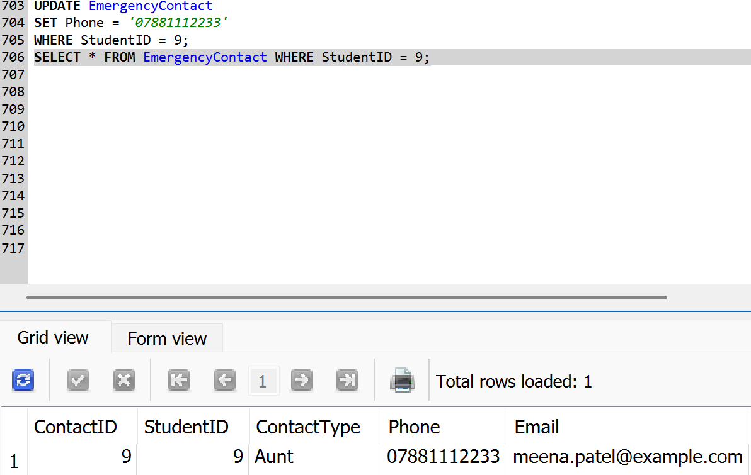

Figure 42: Update contact

## Updating Start Date for Student 'Adam'

To meet task requirements, a student named Adam was added, and their start date was updated using the UPDATE statement. This supports temporal data maintenance and reflects SQL's flexibility for student records (Connolly & Begg, 2021).



Figure 43: Before update

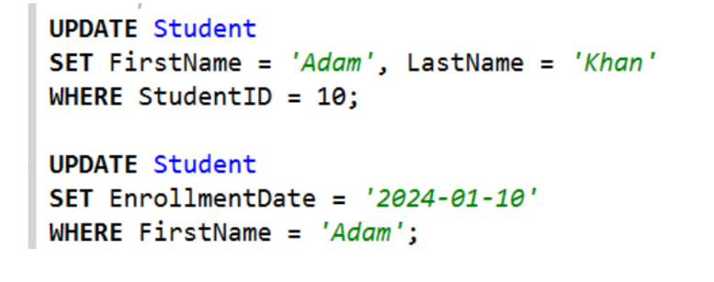



Figure 44: After update

## Integrity Check on Each Table

To validate structural consistency and relational accuracy, an **integrity check** was performed on all key tables within the database using the following command in SQLite:

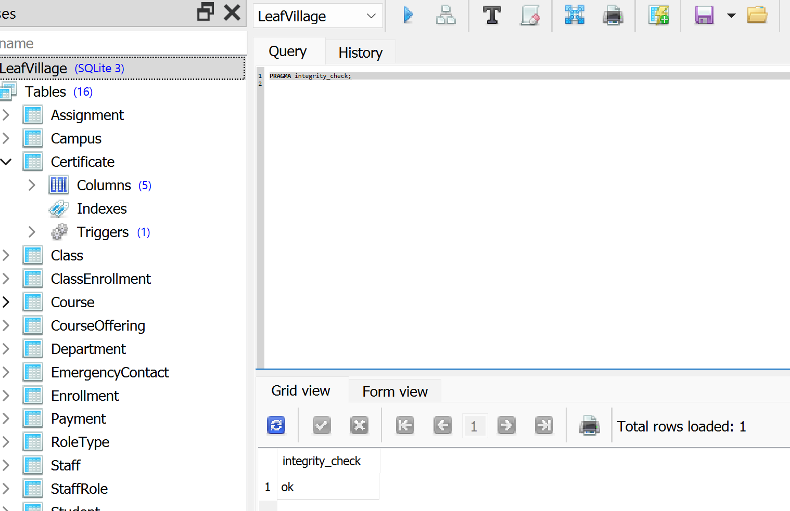

Figure 45 : PRAGMA integrity_check

tables (such as Student, Enrollment, CourseOffering, and Certificate) maintained proper integrity, ensuring the database is stable and compliant with normalization standards (Coronel & Morris, 2019).

## Importance of Integrity Check and Testing Methods

According to Elmasri and Navathe (2016), integrity checks are essential in relational databases to ensure data accuracy, consistency, and referential completeness. These checks verify that primary keys remain unique, foreign keys point to valid entries, and that fields respect NOT NULL or data type constraints. Without them, databases risk data anomalies such as orphaned records or inconsistent joins.

Beyond structural integrity, Coronel and Morris (2019) highlight additional database testing methods, such as query validation, edge-case testing, and simulated inserts and deletions to evaluate constraint responses. Profiling tools, triggers, and type validation are also applied to maintain operational consistency. These techniques help ensure the database behaves reliably and aligns with business logic across various scenarios.

## Exporting View to PDF

The PendingStudents and all offering course views were exported directly from SQLiteStudio into PDF format. This allows clear presentation of pending enrollment data for administrative use (SQLiteStudio v3.4.1, 2024).

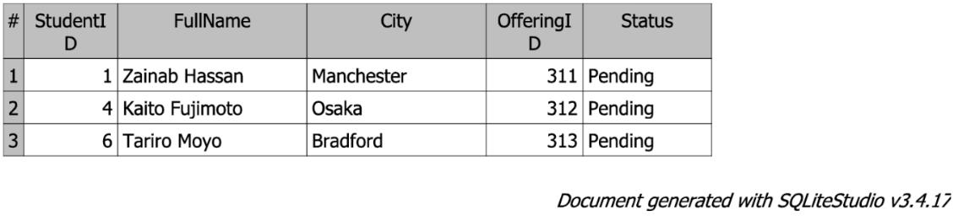



## Exporting Students Table to CSV

The Student table was exported into CSV using Excel's Power Query. This format supports easy integration into other systems and future data analysis tasks (Microsoft, 2023).

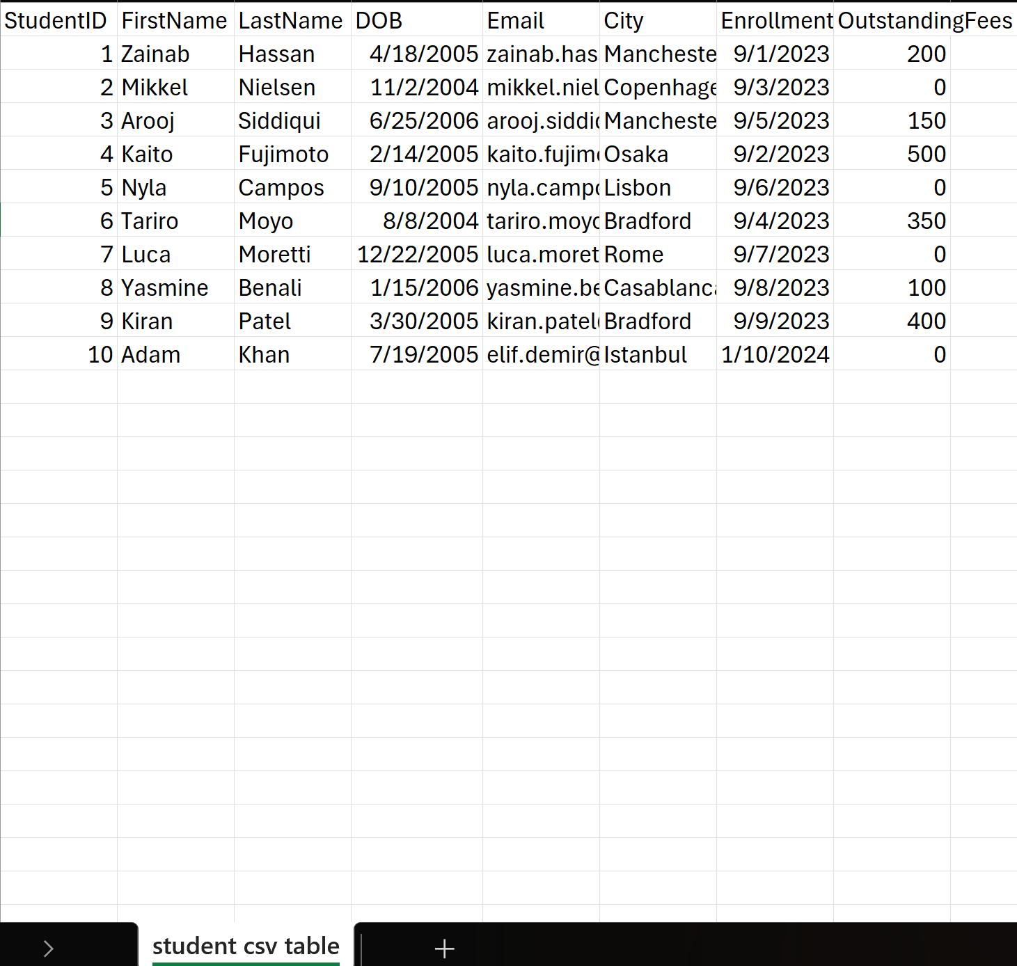

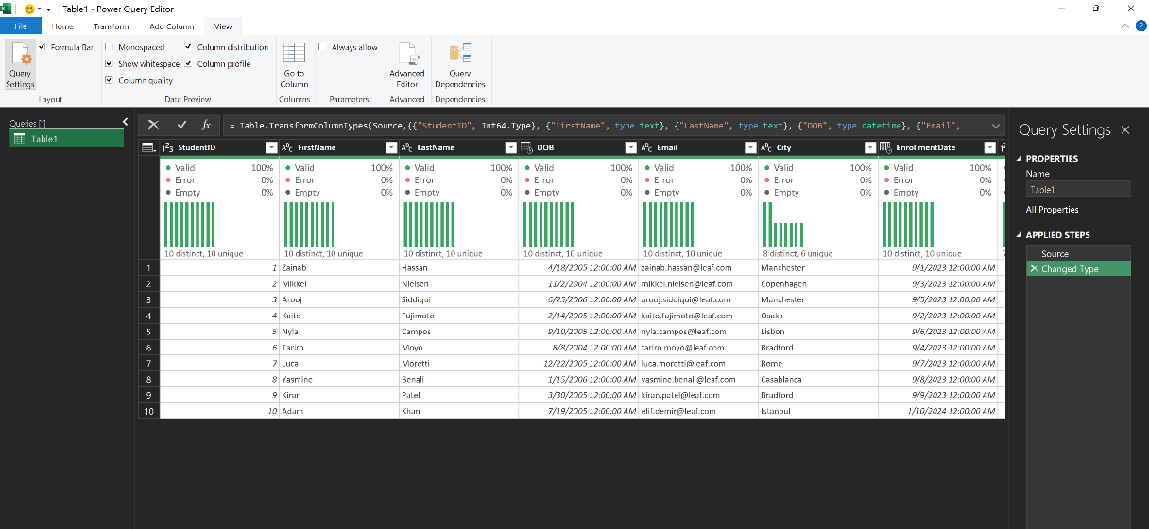

## Power Query Profiling (Course Table)

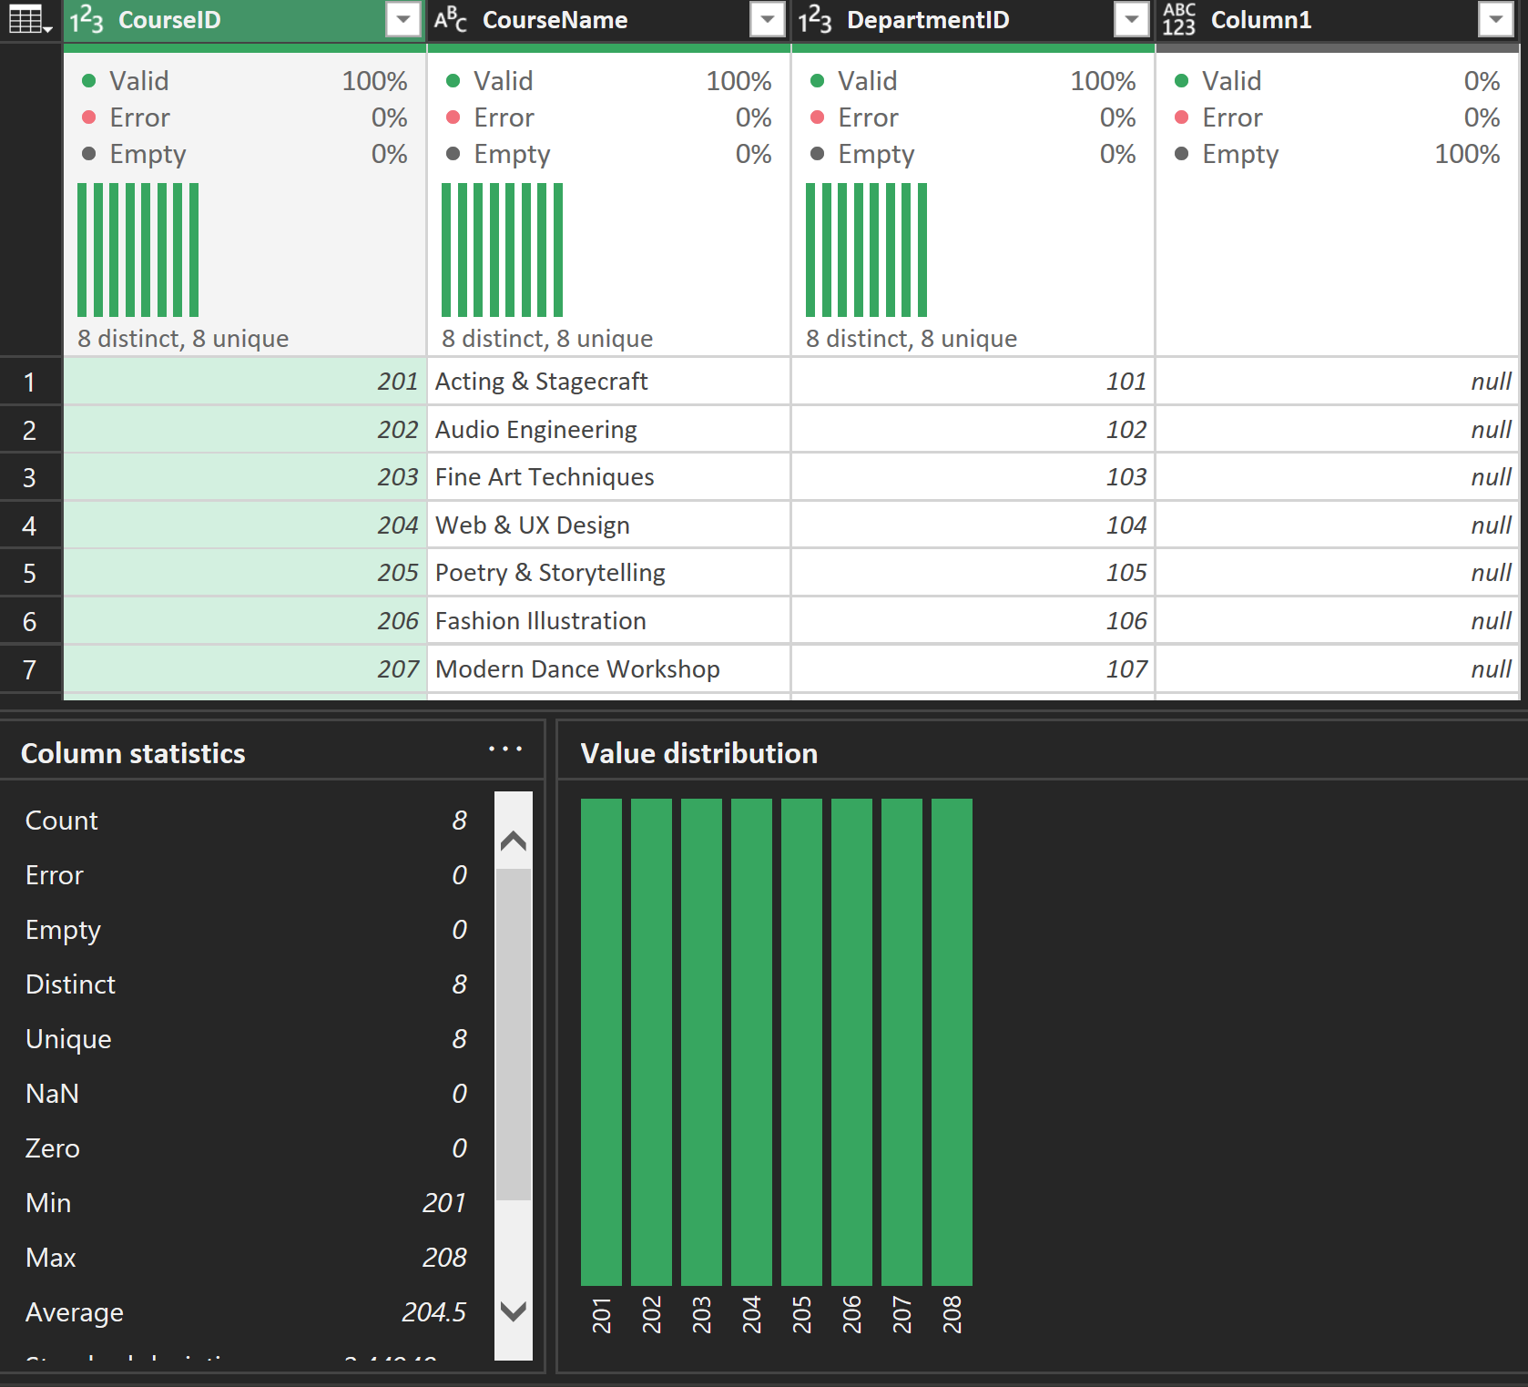Column profiling confirms 100% valid, unique entries for CourseID and no errors or duplicates, ensuring a clean dataset for statistical analysis.

# 4.0 Statistical Analysis

To analyze national distribution and subject-wise trends in online education, a public dataset from Kaggle (Udemy Online Education Courses Dataset) was imported into Microsoft Excel. This dataset contains comprehensive details, including course titles, number of subscribers, course levels, subjects, and user reviews. (Kaggle, 2023).

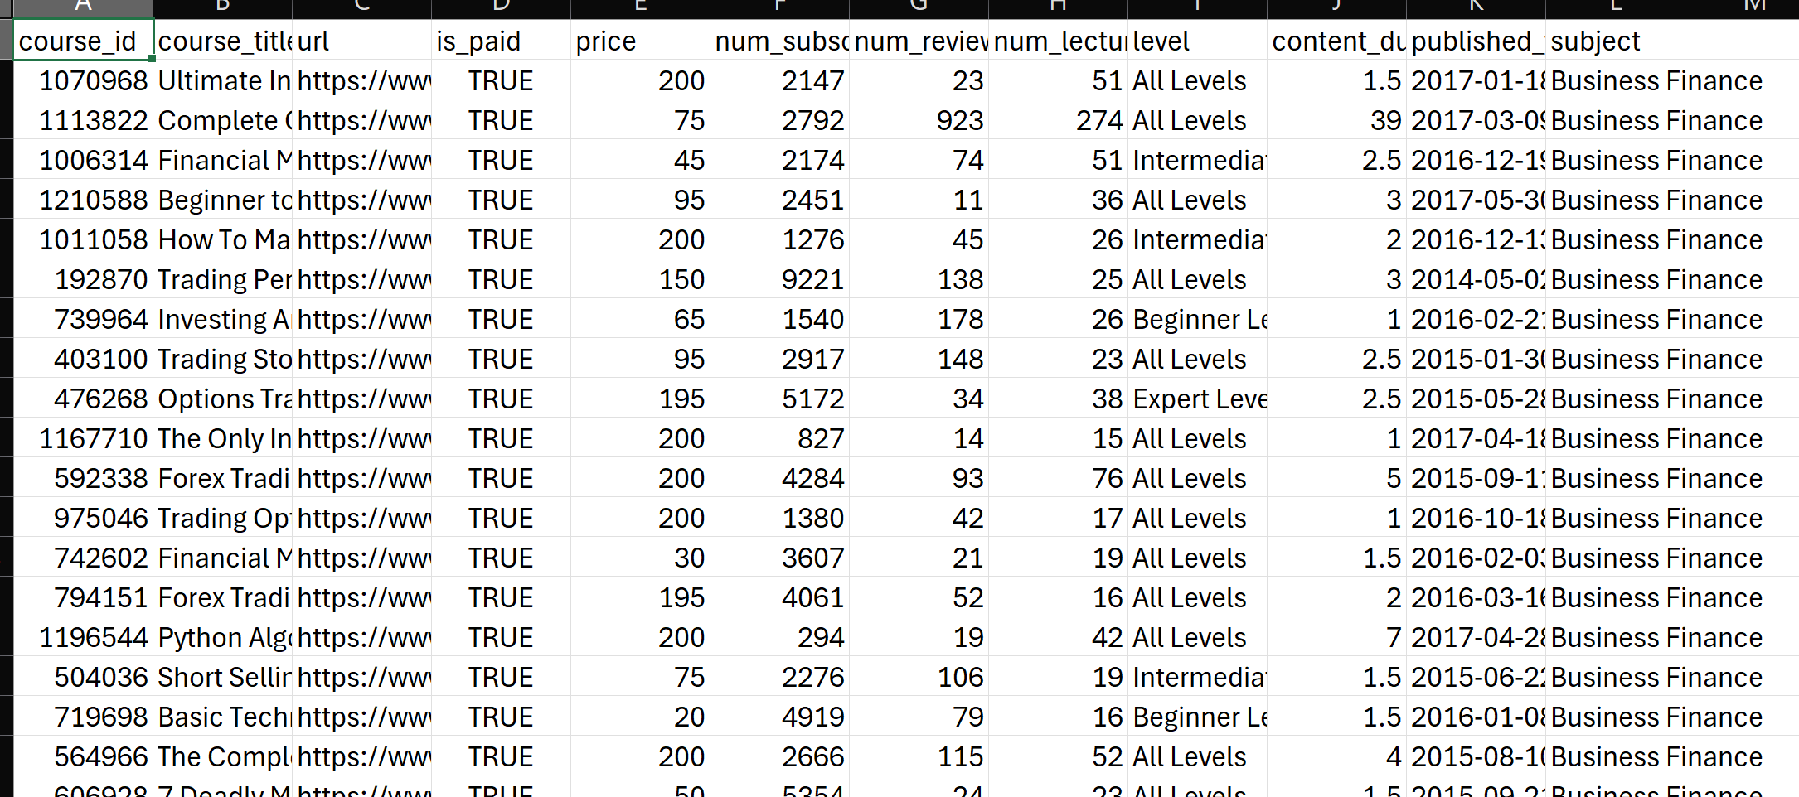

Demonstrates original raw data structure used for generating insights. It shows course-wise values before aggregation.



clean dataset for statistical analysis

## Course Popularity by Subject

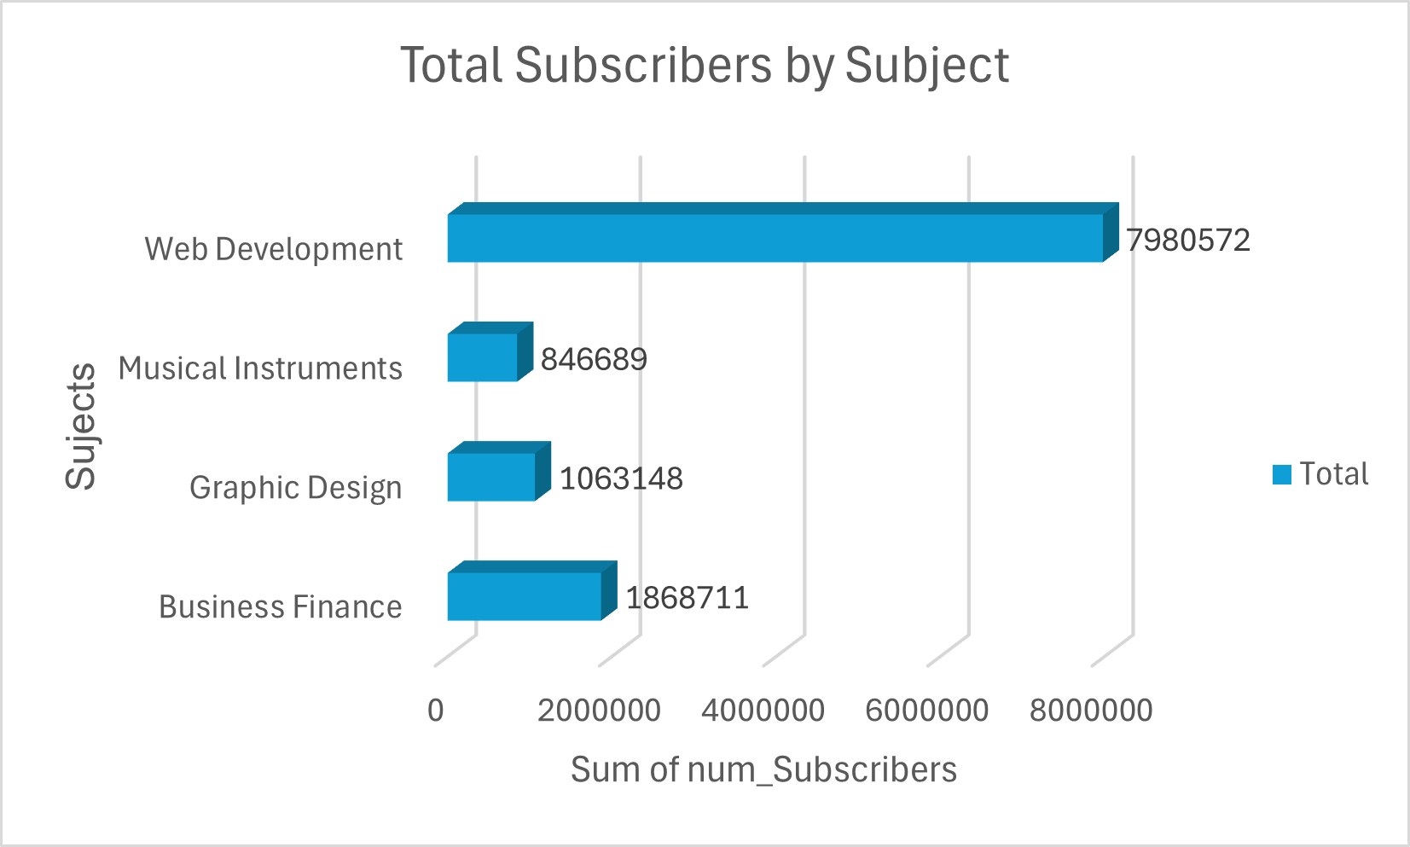

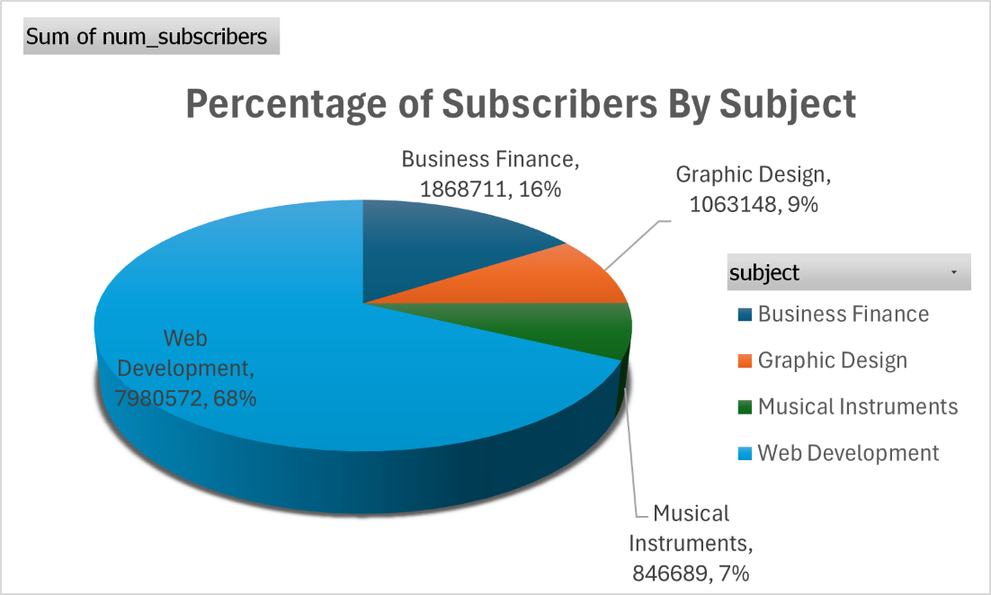

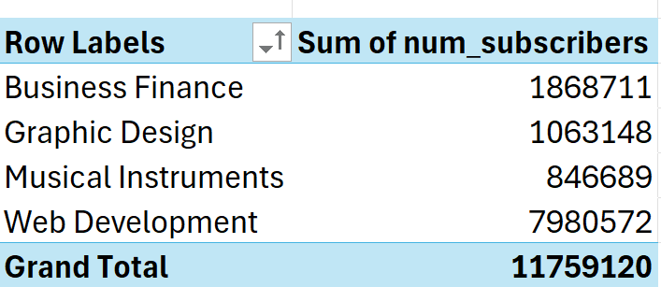

These visuals show that Web Development dominates **67.87%** of all subscribers, followed by Business Finance. The pie and pivot chart supports this distribution and provides an overview of demand across subjects

## Course Popularity by Level

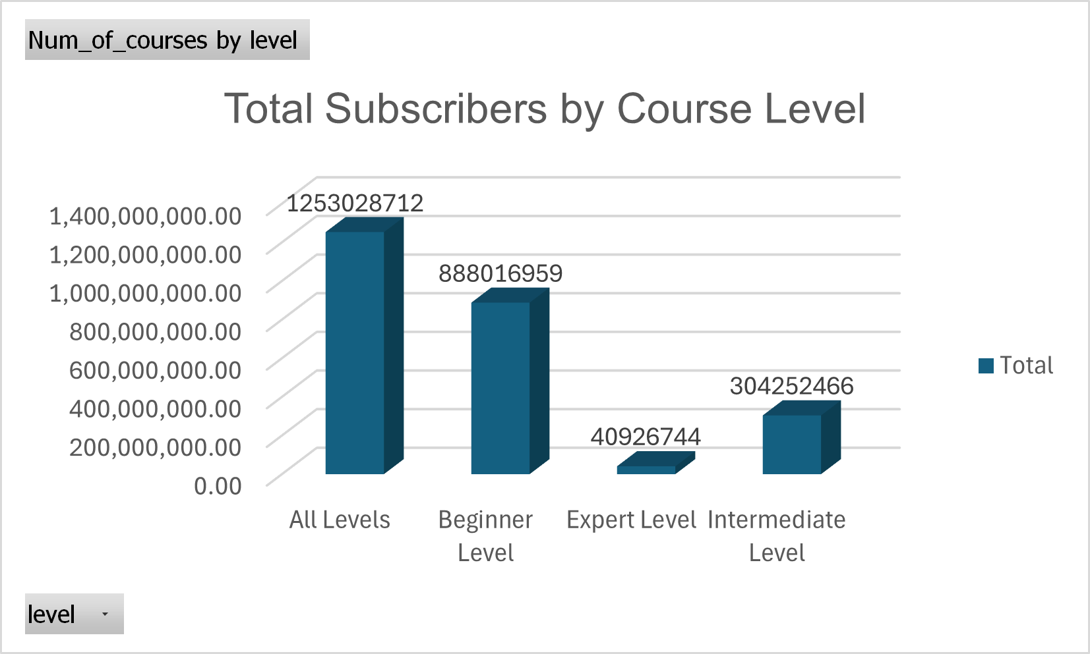

A clear majority of users prefer All Levels and Beginner Level courses. This indicates that accessible content attracts most learners.

## Average Number of Reviews by Subject

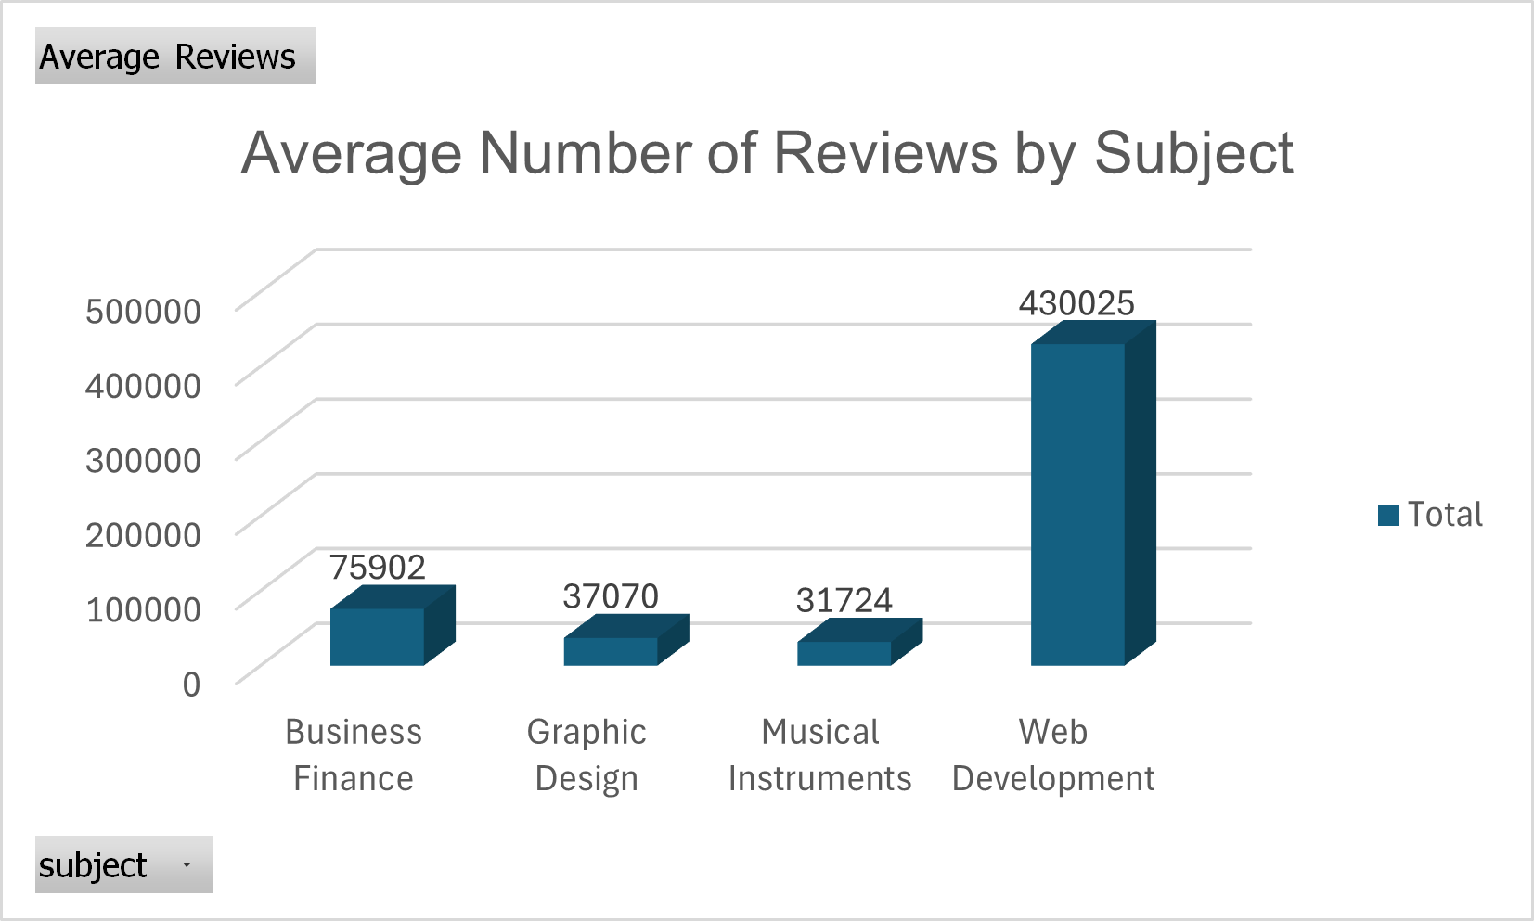

Web Development also received the most average reviews (~430K), indicating high engagement. Other subjects trail significantly, suggesting a possible gap in user interaction.

## Standard Deviation of Subscribers

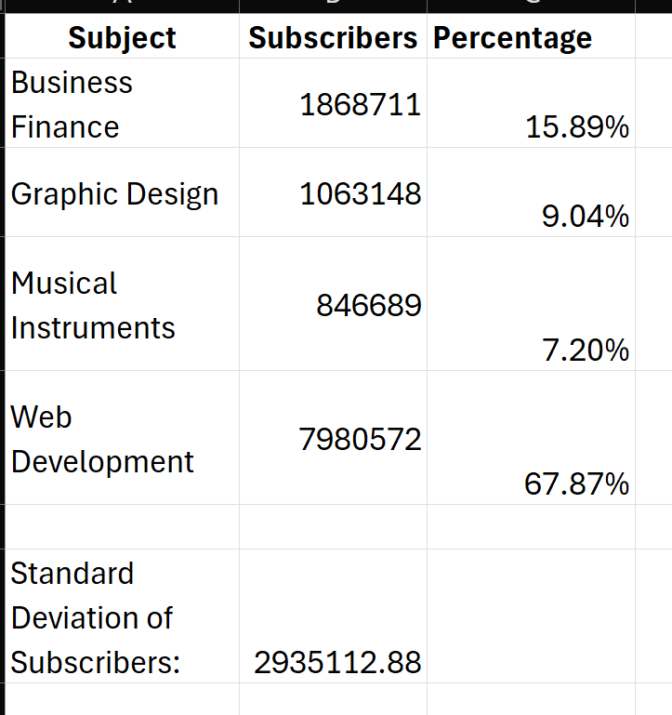

A high standard deviation (~2.9 million) confirms a wide variance in course popularity, mostly due to the skew caused by Web Development courses.

## National Distribution of Subscribers by Subject

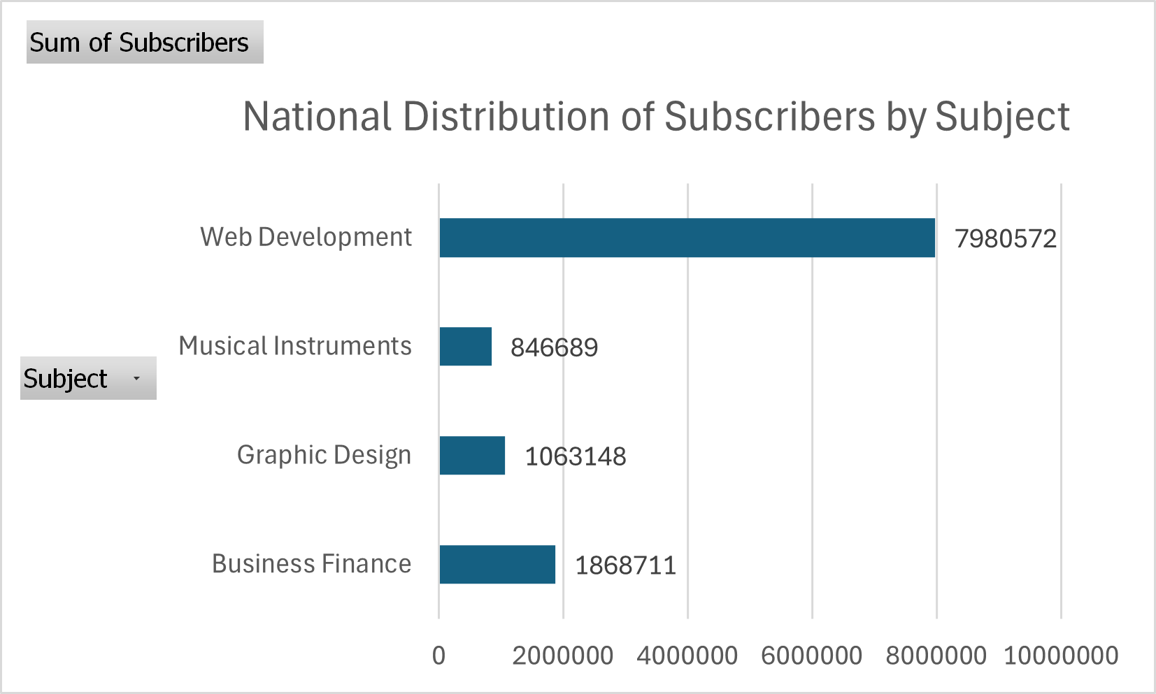

## This supports earlier graphs by showing concentration of subscribers among a few subject areas like Web Development, which significantly outnumbers all other subjects in popularity and demand.

## Statistical Summary and Insights

The analysis revealed enrolment patterns, course demand trends, and revenue variations across offerings. These findings support informed planning for academic and financial optimization.  
These statistical patterns provided actionable insights into learner preferences and institutional efficiency, reinforcing data-informed decisions for future growth (Sharda, Delen, and Turban, 2023).

## LSEPI (Legal, Social, Ethical & Professional Issues)

The Leaf Village database design supports key legal, social, ethical, and professional responsibilities. It does not collect excessive personal information, focusing only on essential fields such as name, date of birth, and contact details, aligning with the UK GDPR principles of data minimisation and lawful processing. From a social and ethical perspective, the system is fair and inclusive, treating all student records equally without bias or discrimination. Professionalism is maintained through well-structured table relationships, normalized schema, consistent field naming, and clear constraints. This promotes system integrity and responsible data handling, in line with ISO/IEC 27001 standards and as recommended by Connolly and Begg (2015) in modern database design practices.

## Conclusion

This project provided a structured opportunity to design, implement, and evaluate a relational database system tailored for Leaf Village Training Ltd. From initial ERD development to advanced SQL analysis, each phase reflected real-world database principles. By implementing normalized structures, default constraints, and triggers, the system reduced redundancies and supported consistent data workflows. For example, junction tables like StaffRole enabled multi-role assignments, and default status values ensured reliable record handling.

Advanced queries uncovered valuable business insights, including student engagement, revenue trends, and instructor workload, enhancing decision-making. Exported views, Power Query visualizations, and statistical tools further strengthened the system’s operational utility. While early iterations lacked automation, testing and refinement addressed these limitations.

The development process reinforced core database concepts, particularly those outlined by Connolly and Begg (2015), such as query optimization, referential integrity, and practical schema design. Overall, the solution successfully merged academic knowledge with professional implementation, demonstrating readiness for real-world database management challenges.

# References

Batini, C., Ceri, S. and Navathe, S.B. (2019) *Conceptual database design: An entity-relationship approach*. 2nd ed. London: Addison-Wesley.

BCS – British Computer Society. (2023) *Code of conduct*. [Online] Available at: <https://www.bcs.org/> [Accessed 16 July 2025].

Chaffey, D. and White, G. (2022) *Business information systems*. 6th ed. Harlow: Pearson Education.

Connolly, T. and Begg, C. (2021) *Database systems: A practical approach to design, implementation, and management*. 7th ed. Harlow: Pearson.

Coronel, C. and Morris, S. (2019) *Database systems: Design, implementation, and management*. 13th ed. Boston, MA: Cengage Learning.

Elmasri, R. and Navathe, S. (2021) *Fundamentals of database systems*. 7th ed. Harlow: Pearson.

Jukic, N., Vrbsky, S.V. and Jukic, V. (2019) *Database systems: Introduction to databases and data warehousing*. 2nd ed. Boston, MA: Prospect Press.

Mannino, M.V. (2020) *Database design, application development, and administration*. 7th ed. Boston, MA: McGraw-Hill Education.

Microsoft. (2023) *Assignments in Microsoft Teams*. [Online] Available at: <https://learn.microsoft.com/> [Accessed 16 July 2025].

Silberschatz, A., Korth, H.F. and Sudarshan, S. (2020) *Database system concepts*. 7th ed. New York: McGraw-Hill.

# Bibliography

Date, C.J. (2019) *An introduction to database systems*. 8th ed. Boston, MA: Addison-Wesley.

Kaggle. (2023) *Udemy online education courses dataset*. [Online] Available at: <https://www.kaggle.com/> [Accessed 16 July 2025].

Rob, P. and Coronel, C. (2018) *Database systems: Design, implementation, and management*. 12th ed. Boston, MA: Cengage Learning.

Sharda, R., Delen, D. and Turban, E. (2023) *Analytics, data science, and artificial intelligence: Systems for decision support*. 12th ed. Harlow: Pearson.

ISO – International Organization for Standardization. (2022) *ISO/IEC 27001:2022 – Information security, cybersecurity and privacy protection*. [Online] Available at: https://www.iso.org/standard/27001 [Accessed 16 July 2025].